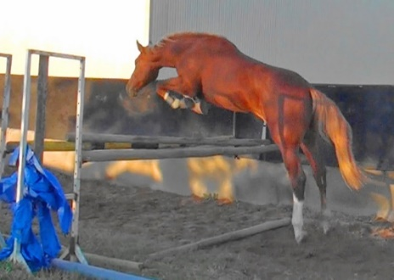
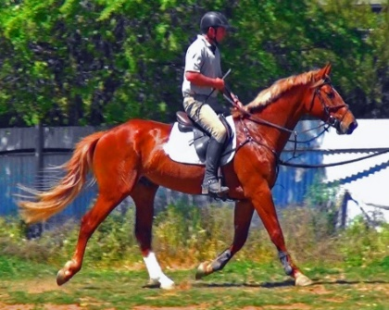
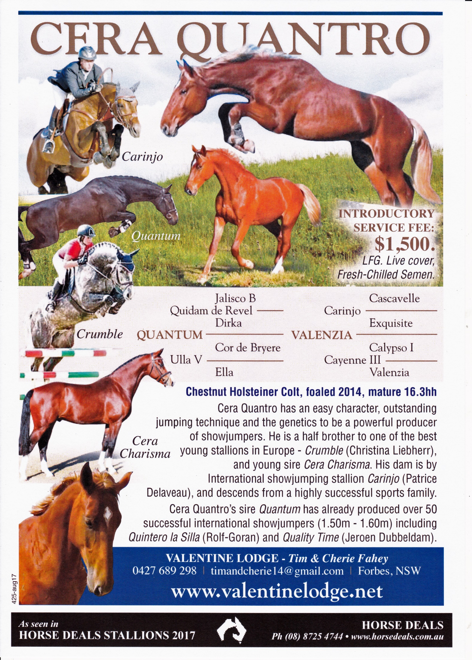Cera Quantro
Chestnut Colt
Mature 16.3hh
Holsteiner
Foaled: 2/11/2014
Quantum /Carinjo / Calypso 1.
Cera Quantro is an exceptionally bred Colt with a easy character and outstanding jumping technique which will serve him well as a competitor and producer. Cera Quantro’s pedigree is full of the most influential sire and marelines in the world for the production of Showjumpers and Sires.
Cera Quantro’s dam Valenzia is a daughter of successful international showjumping stallion Carinjo (Patrice Delaveau), and descends from a highly successful sports family- Holstein Stamm 242. This mareline has produced World class show jumpers and more than 40 approved stallions, which rank amongst the very best in Holstein. Valenzia's sister Nischa was successful to 1.50m level and produced the Reserve licensing champion Con Cosmos. Valenzia has an approved stallion brother, Barkeeper who was also successful in sport, and two other siblings have been highly successful in showjumping. A half-sister to Valencia's dam produced Loro Piana Chiclana who has been successful at the highest level of international showjumping. Valenzia herself has already produced one of the best young stallions in Europe- L.B. Crumble by Colman, now under Christina Liebherr and is competing at 1.40m, as well as the exciting second season sire Cera Charisma by Casall Ask.
Cera Quantro’s sire Quantum completed his approval as Reserve Champion, and today he is a top class inheritor, which transmits his quality to his offspring, he has already produced over 50 successful international showjumpers (1.50m - 1.60m) including Quintero la Silla (Rolf-Goran), Quin Chin (Jasmine Chen), Quality Time (Jeroen Dubbeldam), Fixdesign Chopin (Filippo Marco Bologni), Ulme De Feugeres (Abdullah Humaid Al Muhairi), Silverstras (Jur Vrieling), AD Quantina (Athina Onassis). He is also the dam sire of GK Casper (Bertram Allen), Call Me Liberty, Valdelamadre Clooney (Michael Hughes), For Jack (Emanuele Gaudiano).
Quantum combines two leading sire lines in the Top 100 Sire Rankings for Showjumpers, thru his sire Quidam de Revel, and dam sire Cor de la Bryere. The Olympic Stallion Quidam de Revel's ability to produce top class talent was noticed as soon as his foals started hitting the ground in 1988. In 2004, Quidam de Revel topped the World Breeding Championships Jumping Stallion ratings for the second year running, establishing himself as the pre-eminent – and most expensive – living sire of jumping horses. With ten of his progeny jumping in Jerez 2002, he was the stallion with the most number of progeny at the WEG. A decade later, at the 2012 London Olympic Games, Quidam was still a force, but more through his sons. The success of his offspring has kept Quidam at the top of the WBFSH jumper sire rankings for years.
In 2017 Quidam de Revel himself is ranked 11th in the Top 20 stallion Rankings and another 4 stallions in the top 20 descend directly from Quidam.
- Kashmir V Shutterhof - Grand Sire – No. 6
- Quidam de Revel- No. 11
- Nabab de Reve - Sire - No. 13
- Quasimodo Z- Sire No. 18
- Vigo D'Arsouilles - Grand Sire – No. 20
25% of the Top 20 stallions descend from the Quidam sire line.
Quantum is a direct descendant of the famous Dorette mareline –Holstein Stamm 18b1, which boasts a huge percentage of 1.50m-1.60m jumpers and important stallions. Quantum’s dam Ulla V is the full sister of ’Constant’ the sire of great Olympic competitor and stallion ‘Chin Chin’ and grandsire of exceptional foundation mare Querly Chin. Quantum’s great granddam, Dorette also bred the good sires ‘Roman’ and ‘Farn’, -Farn sired the great grand prix jumping stallion and sire of sires ‘Nimmerdor’.
Cera Quantro is linebred to two of the most influential sires in modern warmblood breeding, being Cor de la Bryere and Landgraf 1, and he combines four of the best female lines out of the top 25 female family rankings in the world for the production of showjumpers, (Sporthorse Breeding Magazine Sept. 2008):

- Holsteiner stamm 776- Ramiro Line: 1st ranked family: Ramiro, Locarno, Promised Land, Acorado 1&11, Landos and Calvados I & II, Lucky Boy and Crunch.
- Holsteiner stamm 18b1 –Dorette: 4th ranked family: Common Sense, Lapacco, Farn, Quantum, Lagos, Constant, Roman & Ronald.
- Holsteiner stamm 162 –Fangelika: 6th ranked family: Coster, Carthago, Lord Calando, Non Stop, Feinschnitt I, Cascavelle, and Lacros & Stanley.
- SF stamm 7 –Nadine: 23rd ranked family: Quidam de revel & Uriel
As well as the important marelines of
- Holsteiner stamm 242 –Diastolchen
- Holsteiner stamm 8777 –Monoline: Cantus, Calvin and Lansing
- Holsteiner stamm 6582- Hyazinthe S : Calypso 1, Calypso 11, Calypso 111, Calypso 1V, Calypso V and Askari
- SF stamm 1 -Tanagra.
- Stamm 318d1- Marietta HSP: Ladalco, Ladalco’s full brother Boy 5 an International showjumper ridden by Eddie Macken. The stallion Cavalor Cumano, Labrador, Little Boy, Casiro 1, Casiro 11.
- Stamm 703- Nina HSP: Carinjo, Rocket Star, Talisman 1, Talisman 11, Landprinz, Landprinz 1, Landprinz 11, Landcolt B.
The strength of Cera Quantro’s pedigree is clearly the versatile background, proven to the Olympic level in all three disciplines.

 |  |  |  | Quantum  HOL-DE/FR-94-DB |  |  |  |  | Quidam de Revel  SF-FR-82-B |  |  |  |  |  |  |  |  |  | Jalisco B  SF-FR-75-B |  |  |  | Almé Z |  |  |  |  |  |  | Ibrahim
 |  |  |  |  |  |  |  |  |  |  |  |  |  |  |  |  |  |  |  |  |  |  |  |  |  |  |  |  |  | Girondine
 |  |  |  |  |  |  |  |  |  |  |  |  |  |  |  |  |  |  |  |  |  |  | Tanagra |  |  |  |  |  |  | Furioso
 |  |  |  |  |  |  |  |  |  |  |  |  |  |  |  |  |  |  |  |  |  |  |  |  |  |  |  |  |  | Delicieuse
 |  |  |  |  |  |  |  |  |  |  |  |  |  |  |  |  |  |  | Dirka  SF-FR-MAR-69-B |  |  |  | Nankin |  |  |  |  |  |  | Fra Diavolo
 |  |  |  |  |  |  |  |  |  |  |  |  |  |  |  |  |  |  |  |  |  |  |  |  |  |  |  |  |  | Constellation
 |  |  |  |  |  |  |  |  |  |  |  |  |  |  |  |  |  |  |  |  |  |  | Ondine de Baugy |  |  |  |  |  |  | Harphortas
 |  |  |  |  |  |  |  |  |  |  |  |  |  |  |  |  |  |  |  |  |  |  |  |  |  |  |  |  |  | Nadine
 |  |  |  |  |  |  |  |  | Ulla V  HOL-DE-82 |  |  |  |  |  |  |  |  |  | Cor de la Bryere  SF-FR-68-DB |  |  |  | Rantzau |  |  |  |  |  |  | Foxlight
 |  |  |  |  |  |  |  |  |  |  |  |  |  |  |  |  |  |  |  |  |  |  |  |  |  |  |  |  |  | Rancune
 |  |  |  |  |  |  |  |  |  |  |  |  |  |  |  |  |  |  |  |  |  |  | Quenotte |  |  |  |  |  |  | Lurioso
 |  |  |  |  |  |  |  |  |  |  |  |  |  |  |  |  |  |  |  |  |  |  |  |  |  |  |  |  |  | Vestale du Bois Margot
 |  |  |  |  |  |  |  |  |  |  |  |  |  |  |  |  |  |  | Ella  HOL-DE-68-B |  |  |  | Colt |  |  |  |  |  |  | Cromwell
 |  |  |  |  |  |  |  |  |  |  |  |  |  |  |  |  |  |  |  |  |  |  |  |  |  |  |  |  |  | Ulana
 |  |  |  |  |  |  |  |  |  |  |  |  |  |  |  |  |  |  |  |  |  |  | Dorette |  |  |  |  |  |  | Monarch
 |  |  |  |  |  |  |  |  |  |  |  |  |  |  |  |  |  |  |  |  |  |  |  |  |  |  |  |  |  | Schelle
 | Cera Quantro
 |  |  |  | Valenzia BP  -DE-0x |  |  |  |  | Carinjo  HOL-DE-01-B |  |  |  |  |  |  |  |  |  | Cascavelle  HOL-DE-86-GR |  |  |  | Cantus |  |  |  |  |  |  | Caletto I
 |  |  |  |  |  |  |  |  |  |  |  |  |  |  |  |  |  |  |  |  |  |  |  |  |  |  |  |  |  | Monoline
 |  |  |  |  |  |  |  |  |  |  |  |  |  |  |  |  |  |  |  |  |  |  | Phaedra |  |  |  |  |  |  | Calando I
 |  |  |  |  |  |  |  |  |  |  |  |  |  |  |  |  |  |  |  |  |  |  |  |  |  |  |  |  |  | Fangelika
 |  |  |  |  |  |  |  |  |  |  |  |  |  |  |  |  |  |  | Exquisite  HOL-DE-90-B |  |  |  | Landgraf I |  |  |  |  |  |  | Ladykiller
 |  |  |  |  |  |  |  |  |  |  |  |  |  |  |  |  |  |  |  |  |  |  |  |  |  |  |  |  |  | Warthburg
 |  |  |  |  |  |  |  |  |  |  |  |  |  |  |  |  |  |  |  |  |  |  | Grossfürstin |  |  |  |  |  |  | Ramiro Z
 |  |  |  |  |  |  |  |  |  |  |  |  |  |  |  |  |  |  |  |  |  |  |  |  |  |  |  |  |  | Vineta
 |  |  |  |  |  |  |  |  | Cayenne III  HOL-DE-88-BR |  |  |  |  |  |  |  |  |  | Calypso I  HOL-DE-MAR-73-B |  |  |  | Cor de la Bryere |  |  |  |  |  |  | Rantzau
 |  |  |  |  |  |  |  |  |  |  |  |  |  |  |  |  |  |  |  |  |  |  |  |  |  |  |  |  |  | Quenotte
 |  |  |  |  |  |  |  |  |  |  |  |  |  |  |  |  |  |  |  |  |  |  | Tabelle |  |  |  |  |  |  | Heissporn
 |  |  |  |  |  |  |  |  |  |  |  |  |  |  |  |  |  |  |  |  |  |  |  |  |  |  |  |  |  | Hyazinthe
 |  |  |  |  |  |  |  |  |  |  |  |  |  |  |  |  |  |  | Valenzia  HOL-DE-83-BR |  |  |  | Ladalco |  |  |  |  |  |  | Ladykiller
 |  |  |  |  |  |  |  |  |  |  |  |  |  |  |  |  |  |  |  |  |  |  |  |  |  |  |  |  |  | Zala
 |  |  |  |  |  |  |  |  |  |  |  |  |  |  |  |  |  |  |  |  |  |  | Lublin |  |  |  |  |  |  | Farnese
 |  |  |  |  |  |  |  |  |  |  |  |  |  |  |  |  |  |  |  |  |  |  |  |  |  |  |  |  |  | Zypresse
Blood Quota of |  | in five / twelve generations

Generation |  |  |  |  | 1 | 2 | 3 | 4 |  | 5 | 6 | 7 | 8 | 9 | 10 | 11 | 12 |  |  | Generation |  |  |  | 1 | 2 | 3 | 4 | 5 | 6 |  | 7 | 8 | 9 | 10 | 11 | 12
21.9% |  | 12.5%  9.4% | Cor de la Bryere |  |  |  | 1 | 1 |  |  | 2 |  |  |  |  |  |  |  |  | 7.0% | 6.3%  0.8% | Dorette |  |  |  |  | 1 |  |  |  | 1
6.3% |  | 0.0%  6.3% | Ladykiller |  |  |  |  |  |  | 2 |  |  |  |  |  |  |  |  |  | 5.9% | 4.7%  1.2% | Furioso |  |  |  |  |  | 1 | 1 |  | 1 |  | 2
3.3% |  | 0.0%  3.3% | Heissporn |  |  |  |  |  |  | 1 |  |  |  | 1

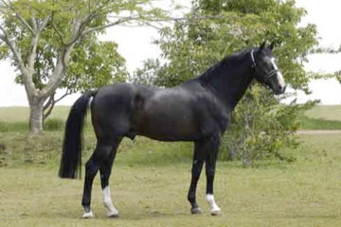
Quantum Quidam de Revel x Cor de La Bryere x Colt
Cera Quantro’s sire Quantum completed his approval as Reserve Champion, and today he is a top class inheritor, which transmits his quality to his offspring. According to the German Equestrian Federation (FN), Quantum had 266 registered offspring in 2012. Of these, 54 horses jump over S level (1.50m-1.60m), which corresponds to a rate of over 20%.
Quantum has produced some really top Grand Prix jumping horses including:
- BMC Quality Time- (Jeroen Dubbeldam) winner in 2012 of the 5 star GP of San Patrignano, -2nd in the 5 star GP of Helsinki, -3rd in the Nations Cup and 8th in the GP of 5 star Calgary and 4th in the Nations Cup of 5 star Dublin.
- Quintero la Silla- (Rolf-Goran Bengtsson) 10th in the World Cup final Geneva 2010, -and in 5 star GPs he finished 3rd Stuttgart, -4th Basel, -6th Rotterdam, -7th Falsterbo all in 2011 and in CSI-Ws he was 3rd in Geneva and in Gottenburg. He was 4th in the Top Ten Final at Geneva and won 1m50 classes at 5 star Paris and Geneva. In 2017 Quintero climbs another 10 places this year to 64, fantastic for a stallion who really didn't breed a lot, and whose strike rate is ahead of most of the top ten.
- Katartina -(Penelope Leprevost) winner of 1m45s at 5 star Aachen CSIO, -Lummen CSIO both 2009 and at 3 star Caen and won the 3 star GP of St Lo in 2007.
- Quin Chin- (Jasmine Chen) 2nd in the 5 star Nations Cup of Gijon and 5th in that of Lummen and in 3 star GPs was 4th in Balve and 5th Redefin in '07 and 5th in Vejer de la Fronterra in ('10).
- Saskia- (Cara Rather) 11th in the 5 star GP of Calgary - 4th in the 4 star GP of Bridgehampton- in 1m50 classes was 2nd at 4 star Calgary - 4th at Wellington 4 star CSIO all in 2012.
- Lerche- (Tamie Phillips) finishad 3rd in a 1m50 class - 5th in a 1m45 class at 5 star Calgary - 6th in a 1m50 class at 4 star Calgary - 2 star GPs at Calgary was 2nd, 3rd and 5th.
- Other Quantum progeny include Silverstras, Marengo, Chopin, Qualifying de Hus, T-Quinta and Candy.
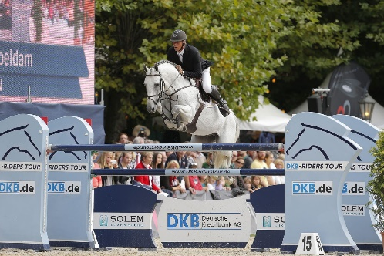
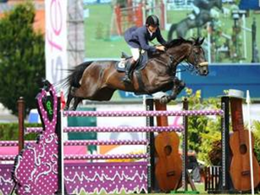
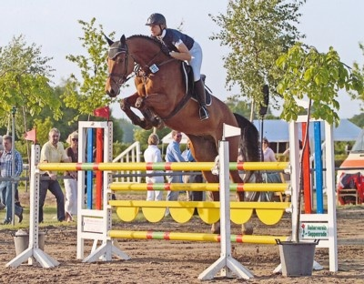

Quantum is a direct descendant of the famous Dorette mareline –Holstein Stamm 18b1, which boasts a huge percentage of 1.50m-1.60m jumpers and important stallions. Quantum’s dam Ulla V is the full sister of the stallion ’Constant’ the sire of the great Olympic competitor and stallion ‘Chin Chin’, she is also the dam of the stallion Serrano, and mare K-Quintana- dam of approved stallion Castar Cooper a winner of CSIO4 *. Quantum’s grandam is the mare Ella which produced the stallions Constant and Randers and the mares -Nato (by Ronald), Ode (Ronald)- produced three 1.50-1.60m competitors -Romulus, Amoroso, Nolde. Another daughter Palisa (by Cor de la Bryère)- is the dam of Queen Liesa 1.60m,Cardamomo 1.40m. Ella is the grandam of 1.60 competitors including Horse Gym’s Champagne 1.50m, Evli Gaglistro 1.60m, Waldes 1.50m. Quantum’s great granddam, Dorette also bred the good sires ‘Roman’ and ‘Farn’. Roman was a top class dam sire we find him in the pedigree of many International sport horses and approved stallions like Cantus, Calvin Z, Lansing, Carolus I and II, Carry, Lux Z and Tin Rocco. Farn sired the great grand prix jumping stallion and sire of sires Nimmerdor and is the dam sire of the stallions Kannan and Big Star. Dorette also produced the mare Adrette dam of the stallion Ronald a very important dam sire. Female offspring by him went on to produce Captain Incipit, Coretto, Landetto, Larno I and II, Latouro, Le Grand I and II, Libero H, Londron, Lord Incipit I and II.
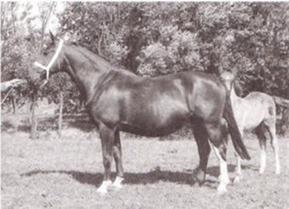
Dorette HOLSTEIN STAMM LINE 18B1
A legendary Stamm Line- Holstein Stamm 18B1: The mare Lisch (v. Alex) bred by Theis Thomahlen and foaled in 1861, produced four daughters who in turn formed the basis of a Holsteiner mare line stamm 18. Lisch was the root of Stamm18. Her daughter Delphine is the basis of strain 18A1, Brame of 18A2, Ella of 18B1, and the mare Bellona was the matriarch of 18B2. Although many lines of Holsteiners did not survive the industrial revolution, the Thormahlen’s loyalty and diligence with their horses continued the 18A1, 18A2, and 18B1 bloodlines. Only 18B2 completely died out. The 18B1 line continued and became a major influence in breeding Holsteiner jumpers and elite sport- horse jumpers world wide, and today is a major Influence in modern day Showjumping at top levels in sport.
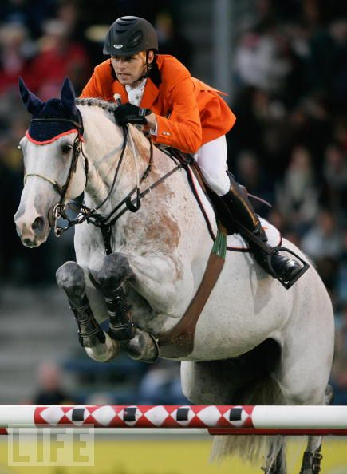
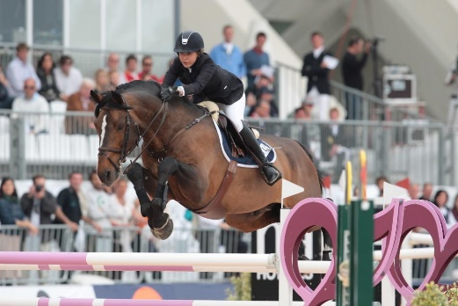
From the Maalwater Elite Auction we have an in depth description of the 18B1 line: “18B1 Stamm is the sports-line par excellence! The current standard-bearers in jumping include Audi's Alpapillon Armani (v. Aldato) with Vincent Voorn, Queen Liesa (v. Quidam de Revel) under Felix Hassmann, Romulus 105 (v. Ramirado) under Otto Becker, Cagliostro (v. Calando I ) under the Finnish rider Noora Pentti, Catwalk 7 under Christian Ahlmann and Campesino (v. Cor de la Bryere) under Thomas Voss, Cardoso vd Helle (v. Calando I) with Christof Cleeren, and the Olympic Games participant Common Sense (v. Candillo), who was partnered by Russia's Mikhael Safronow.
This strain has also produced many approved stallions, some of which stamped their mark on breeding in the Netherlands. The best known are: Farn (sire of Nimmerdor and Wolfgang), Lagos and Ronald. The Cor de la Bryere son Constant has produced many good horses, including Chin-Chin, who was 4th at the Olympics in Barcelona and grandsire of the exceptional foundation mare Querly Chin. Other approved stallions from this line are: Rembrandt, Laudon, Leonino, Country Down, Rheinberg, Quantum, Legendär I and II, Sandos, Marquis, Calmaro, Nestor and the half-brother of Farn, Roman.
The mare Dorette (born 1945, v. Monarch), through her sons Farn and Roman, and her daughters Adrette and Ella, have had a major impact on breeding in Holstein and beyond.
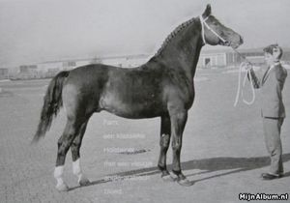
- Farn spent one season in Holstein before moving to Holland where he produced many top horses for sport and breeding. Farn sired the great grand prix jumping stallion and sire of sires Nimmerdor which is also the dam sire of the stallions Kannan and Big Star.
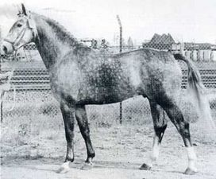
- Roman had few direct sons approved, but we find him in the pedigree of many International sport horses and approved stallions as the damsire to Little Rock, Cantus, Lansing, Calvin Z, Carolus I and II, Carry, Larome Lux Z, Carry, Lagano, Privet, L 'Amour (Nocturne), Cordeur, Corr Adus, Montevideo, Rouletto and Tin Rocco.
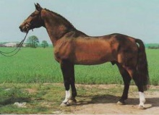
- Adrette (born 1964, v. Heilbutt) is the mother of the stallion Ronald. He produced the stallions Rocadero, Ricardo and Randers. More important is Ronald’s role as sire of stallion mothers. Female offspring by him went on to produce sires such as: Captain Incipit, Coretto, Landetto, Larno I and II, Latouro, Le Grand II I and II, Libero H, Londron, Lord Incipit I and II.
- Ella (born 1968, v. Colt from Dorette) produced 10 offspring amongst these are the full siblings Constant, Ulla V and Palisa all by Cor de la Bryere, the mare Ode by Roman and the stallion La Sauvage by Le Grand 1.
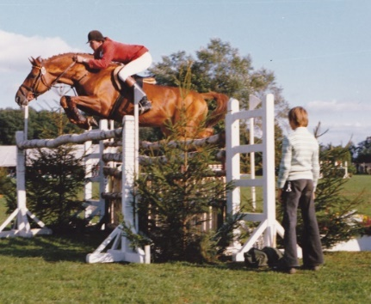
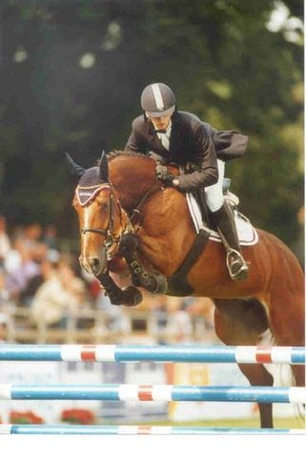
- Constant by Cor de la Bryere from Ella- because of his chestnut color Constant was relatively underused and he died at a young age. Constant jumped internationally with Dr. Rüping and Hans-Günther Winkler. His most famous son is Chin Chin, individually 4th at the Olympic Games in Barcelona and the sire of London Individual Silver medallist Glock’s London, Arezzo VDL, Triomphe de Muze and the exceptional foundation mare Querly Chin. Constant as a father of stallion mothers we find him in the pedigree of Campinos, Chacon, Confusion M, Libertino I and II, Ramirado and International jumping gelding Cöster (v. Calato) under Christian Ahlmann.
- Ulla V by Cor de la Bryere from Ella is a full sister of the stallion Constant. Ulla V is the dam of the Holstein stallion Quantum (Quidam de Revel) reserve champion at his approval and has proved himself as a top class inheritor who unquestionably passes on his quality to his offspring. Quantum’s full sister K-Quintana produced the approved stallion Castar Cooper a son of Caretano.
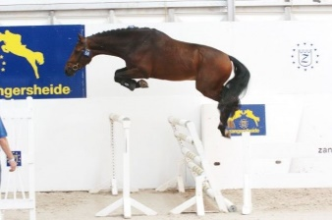
- Palisa by Cor de la Bryere from Ella produced 1.60m competitor Queen Liesa, ridden by Felix Hassmann, and is the grandma of Horse Gym's Champagne.
- Ode by Roman from Ella produced three 1.50m-1.60m horses. ROMULUS 105 by Ramirado- AMOROSO (Amoroso van de Helle) by Acorado I) and Nolde by Nekton.
- Randers bay stallion by Ronald from Ella.
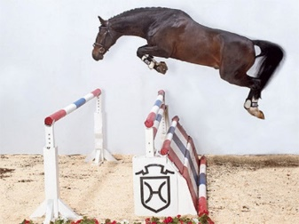
- Zilia by Liostro from Ella produced the 1.60m competitor Evli Cagliostro.

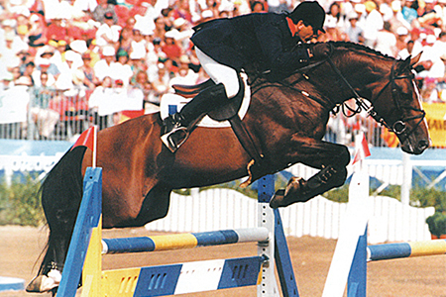
Quidam de Revel
by Jalisco B from Dirka 1982 – 2014 169 cm Bay
In 2004, Quidam de Revel topped the World Breeding Championships Jumping Stallion ratings for the second year running, establishing himself as the pre-eminent – and most expensive – living sire of jumping horses. With ten (!) of his progeny jumping in Jerez 2002, he was the stallion with the most number of progeny at the WEG. A decade later, Quidam was still a force at the London Olympic Games but more through his sons. Quidam had one representative, while his son Nabab de Reve had four, and his son, Kashmir van Schutterhof, one. Another Quidam son, Quasimodo Z had two, with singles to Vigo d’Asouilles, Guidam and Dollar da la Pierre.
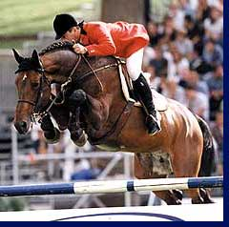
Quidam was himself a jumping star, a member of the French Olympic Team, and fourth individually at the Barcelona Olympic Games with Hervé Godignon. A year later the patriotic French breeders were shocked when Danish businessman, Flemming Velin purchased the stallion and he moved to stand in Denmark.
The Quidam story (excellently told by Marc Verrier in Annuaire Monneron 2005) begins in 1935, when the mare, Nadine (Issu d’Amblie / Sérieux) was sold by her breeder, Léon Brohier (uncle of Jean, the breeder of Narcos II and Quat’Sous) to the Clodus family, to draw their carriage.
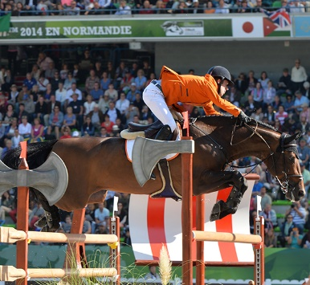
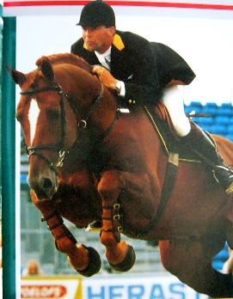
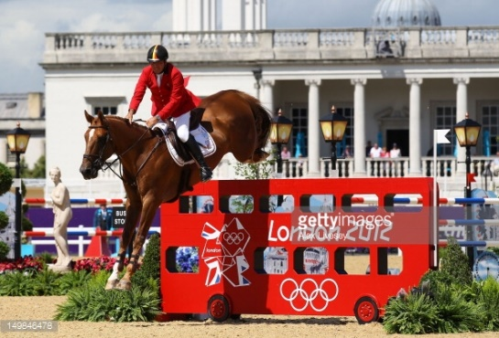
Nadine – she started it all…When Marguerite Clodus married Jacques Savary in 1950, she brought Nadine with her. Ridden by both husband and wife, Nadine gave birth to four foals, including three fillies that were to become famous with the affix – de Baugy.
Bred to Ascot, Nadine produced Ismène de Baugy, Jésabelle de Baugy, and when bred to the Thoroughbred, Harphortas. Nadine produed Ondine de Baugy: who when bred to Nankin, produced five fillies, the most famous of which are Bérénice and Dirka which is the dam of Quidam de Revel. Dirka, who did not carry the de Baugy affix, was sold as a three year old to the Prince de Broglie. Nelson Pessoa, rode her to CSIO level, later she was ridden by Xavier Leredde (son of the breeder, Fernand Leredde) and finished her competition career in his hands. She was retired from competition in 1979. Bred to San-Souci, Dirka produced Orka de Revel and Paprika de Revel, both successful jumpers. Following the election of François Mitterand, the Prince fearing for his fate under a left-wing government, fled to Switzerland, leaving Dirka in the care of Fernand Leredde.
Young Xavier was starting a successful jumping career with Jalisco B – and the young stallion was a natural choice. In January 1982, Dirka gave birth to Quidam de Revel. When covered again by Jalisco, she produced the broodmares, Razzia and Sarah de Revel. With Jalisco’s half brother, Kissovo, she produced CSO winner, Vallon Rouge, and with Narcos, Aiglon Rouge, a star in Holland. With Quat’sous, she produced Byra Rouge, and with Papillon Rouge, Dirka de Revel. What a mare!
Quidam was sold at the age of 18 months to Mr Barbier, who then sold the colt to the Mazé family, and their daughter Sophie was the first to experience the emerging superstar. At the end of Quidam’s six year old season, Sophie Mazé offered the ride to Hervé Godignon. The combination was an immediate success, winning the European Championships at La Baule in 1991, and missing a bronze medal by the narrowest of margins at the 1992 Olympics in Barcelona. In June 1993, he was purchased by the Dane, Thomas Velin.
In an article in HORSE INTERNATIONAL (No 1 – 2003), Velin told the journalist, Pernille Linder Velander: “I am a Thoroughbred person. Quidam is the kind of horse that appeals to me. He is a perfect beauty. If you compare him to the legendary Northern Dancer, you could hardly tell who is who. They could be twins.”
But Mr Velin got more than a breeding stallion, he purchased the ultimate ‘school-master’ for his son, Thomas, taking him on to win such prestigious events as the Grand Prix of Hannover. According to Thomas: “The feeling I got from Quidam has taught me what it should feel like to sit on a really good horse. If you have not had that experience, you simply cannot imagine what it can be like. When in the air, if needed, Quidam could just… like put in another gear, make another effort and jump higher still even after taking off from the ground.”
Quidam de Revel unites two of the most important lines of the Selle Français horse – the lines of Jalisco and Uriel. The Nankin son, Uriel was one of the most successful French stallions, producing more than 100 international showjumpers, which gave him a jumping index of 121, the highest recorded in France at the time. Uriel was the sire of 26 stallion sons – including Calvados who was influential in Holland, standing at the Nijhof stud.
Jalisco is a legend in his own right, but Quidam’s dam was also a star – Dirka, despite being only 163 cms, won at international level with Nelson Pessoa, before being given to Xavier Leredde who made his junior international debut on her.
Verdi, a member of the Gold Medal winning Dutch team at Normandy…
Performers by Quidam de Revel include: Goldy, Guidam, Circa Z, Tlalloc La Silla, Nabab de Rêve, Dollars Boy, Hermès St Lois, Happy Villers, Jadis de Toscane, Belsedène d’Amaury, Bamby II, Baie Mahault, Coucou des Vivreau, Demie-Lune, Darios V, Furka du Village, Huppydam des Horts, Eve des Étisses, Daibolo du Parc, Dolovia de Sapaie, Drakkar de Phaële, Diam de la Ressée, Daibolo du Parc, Étoupe, Bianca d’Amaury, Eyken des Fontenis, Electra d’Amaury, Éburovic Granpré, Coco Chanel Trèfle, Billy de Forcilles, Happy Villers.
In the survey of the world’s top 75 jumping sires that appears in the French publication, Monneron 2007-2008, Quidam de Revel was Number 1 with 48 CSI winners and he was also represented by two sons. Nabab de Reve (out of an Artichaut mare) is 18th with 14 CSI winners, while Guidam (out of a Vénutard mare) ranks 19th with 12 winners, including Authentic, second best performer in the world in 2006 and winner of the Grand Prix of Aachen in 2007.
As a sign of the times, Quidam de Revel is listed in the 2015 Hanoverian Stallion Yearbook, where he is recorded as having 402 competitors with winnings of €1,898,770 with 138 competing at S level. He has 27 horses with over €15,000 in prizemoney. Four horses have won more than €100,000: Queen Liesa with €182,186, Quel Homme 3 with €138,744, Quibell with 123,829 and Diablo du Parc with €103,493. Queen Liesa (Holstein branded, and out of a Cor de la Bryère mare) was a solid performer with Felix and Toni Hassmann, but no super star. Her best result in her final year of competition, 2009, was a 1st in a 1.45 class at Bremen.
For 2014, Quidam has an FN jumping breeding value of 139. His dressage ranking is 85. On the Hanoverian mare test scores, he has a negative 79 for type, and even a negative 95for limbs. On the Hanoverian values based on mare tests and auction examinations, he has a 79 for dressage and 143 for jumping.
On the WBFSH stallion rankings for 2014, Quidam de Revel is in 10th with by far his most successful representative, Verdi.
At the European Championships in 2013, he was represented by Verdi, who finished in 21st on the individual standings. Verdi was also a member of the Dutch Gold Medal winning team at the WEG in Caen, and the highest ranked Dutch horse at the London Games.
In the magazine le Selle Français (no 16 – 1st Trimestre 2013), Bernard le Courtois looked at the top 15 stallions of the 2012 season and Quidam was top of the list, with 8 winners in the season – equal with Kannan. However, he ranked 7th on the list of stallions ranked by the number of winners to number of progeny – with 8 out of 425 foals born between 1999 – 2003, a ratio of 1.88%.
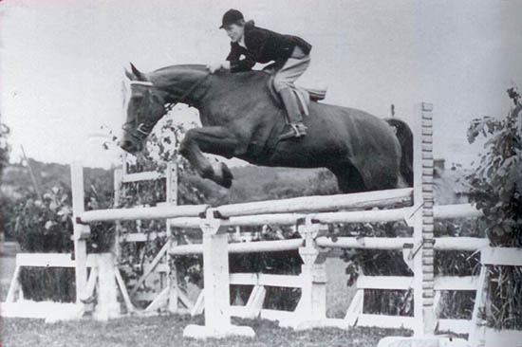
Nadine SF Stamm 7 by Issu d’Amblie
Nadine- 1935, (Issu d’Amblie / Sérieux) was sold by her breeder, Léon Brohier to the Clodus family, to draw their carriage. When Marguerite Clodus married Jacques Savary in 1950, she brought Nadine with her. Ridden by both husband and wife, Nadine gave birth to four foals, including three fillies that were to become famous with the affix – de Baugy.

Nadine Produced
- Ismène de Baugy by Ascot: a winner in 4 year old classes before she went on to produce Quadrille C, another good competitor.
- Jésabelle de Baugy by Ascot: a winner at CSO level, but more famed for her foals:
Troubadour, winner of the 6 year old Criterium, Commander and Daguet de Baugy – all three of them won CSIs. Jésabelle also produced Uriel, an excellent sire whose daughters nicked especially well with Almé’s descendants – most notably Jalisco B. The most famous result of this cross being the stallion, Dollar de Murier. Uriel may be considered with Ibrahim, one of the founding stallions of the Anglo Normand part of the SF Stud Book, and he was the sire of many great jumpers.
- Ondine de Baugy by the Thoroughbred, Harphortas: a ‘pretty but difficult’ mare, who when bred to Nankin, produced five fillies, the most famous of which are Bérénice and Dirka.
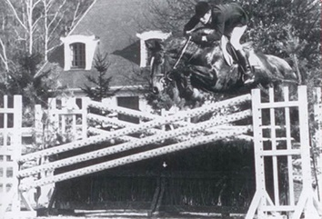
- Bérénice by Nankin produced the showjumping winners, Gamin de Baugy and Nadir de Baugy, as well as the stallions, Cheyenne de Baugy (sold to Belgium) and the National Stud stallion, Veneur de Baugy. She also produced Lady de Baugy, dam of the jumper, Rodéo and the stallion, Sioux, a good performer who stood in Belgium before being purchased by the French National Stud.
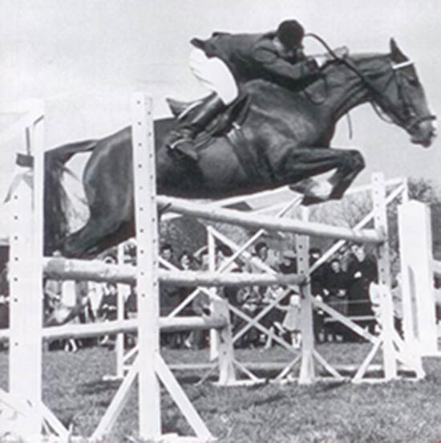
- Dirka, by Nankin who did not carry the de Baugy affix, was sold as a three year old to the Prince de Broglie. She performed well as a six year old (22nd of her generation) before being sent to Nelson Pessoa, who rode her to CSIO level, winning many speed classes. Later she was ridden by Xavier Leredde (son of the breeder, Fernand Leredde) and finished her competition career in his hands. She was retired from competition in 1979. Dirka when bred to San-Souci, Dirka produced Orka de Revel and Paprika de Revel, both successful jumpers. Following the election of François Mitterand, the Prince fearing for his fate under a left-wing government, fled to Switzerland, leaving Dirka in the care of Fernand Leredde. Young Xavier was starting a successful jumping career with Jalisco B – and the young stallion was a natural choice to join to Dirka. In January 1982, Dirka gave birth to Quidam de Revel. Back to Jalisco, she produced the broodmares, Razzia and Sarah de Revel. With Jalisco’s half brother, Kissovo, she produced CSO winner, Vallon Rouge, and with Narcos, Aiglon Rouge, a star in Holland. With Quat’sous, she produced Byra Rouge, and with Papillon Rouge, Dirka de Revel.
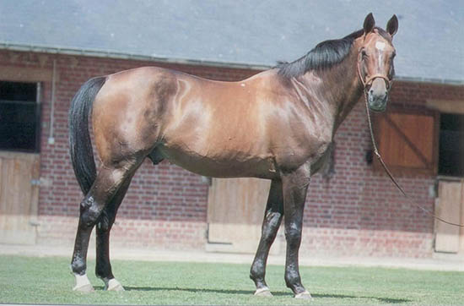
Jalisco B by Alme from Tangra W by Furioso 1975 – 1994

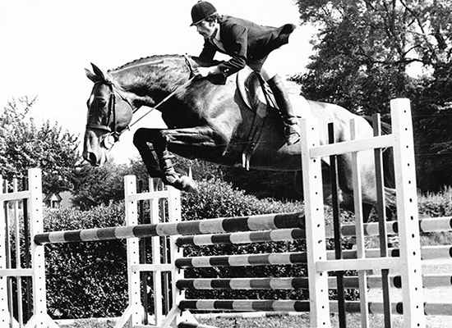
Like so many of the great stallions, Jalisco was not an
immediate star. As a five year old, he finished a respectable 8th at the French championships, the following year, he was 8th in the Grand Final, and ranked fourth in prize money earned of his generation.
Teamed with Xavier Leredde, son of the famous breeder, Ferdinand Leredde, Jalisco won the Grand Prix of Paris in 1983, and was on the selection list for the 1984 Olympic Games in Los Angeles. Before he had the chance to compete at the Games, he was injured on the Spanish circuit, and sold to Portugal, and competed for that country with Manuel Malta da Costa at the Seoul Olympics in 1988.
He returned to France in 1988 to a breeding career – but was limited in the number of mares he could cover as his semen was not suitable for freezing, or even chilling and transporting. He served for only three seasons before being struck down by colic at the beginning of the 1994 season. He was 19 years old.
Jalisco was bought as a two year old by Henriette Van Riemsdijk – later to become the wife of French breeding expert, Arnaud Evain. Henriette knew very well Jalisco’s sire, Almé who had been broken in and trained at her stable, eight years earlier. While Jalisco was in her possession, she gave him to Xavier Leredde to ride, and decided with Fernand Leredde only to breed her stallion to mares with performance or breeding.
In 1980, international jumping star Olisco, was foaled – he went on to compete internationally with Michael Matz; the following year, Privilége (Helmut Morbitzer) and – with M. Leredde taking his own advice – Papillon Rouge.
Leredde also bred Rochet M, a bronze medal winner with Alexandra Ledermann at Atlanta.
In an interview with Xavier Libbrecht in Breeding News in February 1997, Fernand LeRedde has this to say about the stallion:
“One should consider that Jalisco has four half brothers, sons of Almé, from a generation which distinguished itself at an equivalent level of competition. In no particular order, and with some different results, there is Joyau d’Or A (Fabulation by Vin d’Honneur SF), I Love You (Elyria by Nykio SF), Lord Gordon (Taviane by Brule Tout SF) and Galoubet (Viti by Nystag TF). Assuredly, Jalisco has not been the most dazzling performer of the lot. Joyau d’Or and Lord Gordon had short or interrupted careers, I Love You, winner of a Volvo World Cup Final (Vienna 1983) and Galoubet have been more spectacular than Jalisco in the ring. But, there again, history proved that Jalisco used his weaknesses to his advantage. Out of the five, he was the biggest, moved with the greatest elasticity, with the longest stride. He was also, intrinsically, the most powerful. His pedigree and, notably, his maternal line, was perfect, since his mother, Tanagra, pride of the Sabras breeding, never produced anything other than good horses (Geisha N, Danoso etc.). On the other hand, he was sometimes a little phlegmatic and lacked respect for obstacles, and his competitive honors were never as high as those of his half brothers. However, fifteen years after the end of his sporting career, he was considered to be the best stallion of the five best French Almé sons of his generation.”
In 1982, Jalisco sired two stallion stars – Quidam de Revel, 4th at Barcelona who went on to be for a while the world’s most expensive – and successful – stallion, and the 1990 World Champion, Quito de Baussy.
By 1995, Jalisco was number one on the WBFSH rankings with eight horses competing at the highest international level. At the 1996 Olympic Games, he was represented by Rochet M, Surcouf de Revel, Vert et Rouge and Revoulino.
According to Arnaud Evain: “What Jalisco brought was the scope – scope and long strides. Behind his very strong body there was a lot of blood, but you must have a lot of respect and passion with the Jaliscos because they are generally not very spectacular when they are four. When you combine the blood of Jalisco with the blood Nankin or his son, Uriel that is often very successful. Quidam de Revel, is Jalisco / Nankin, Dollar du Murier is Jalisco / Uriel. You find that quite often.”
In the survey by Bernard le Courtois of the top 75 stallions of 2006, Jalisco is ranked =30th with 10 representatives.
Jalisco was the sire of 63 approved stallion sons, but the most important has been Quidam de Revel and his sons, Guidam and Nabab de Reve.
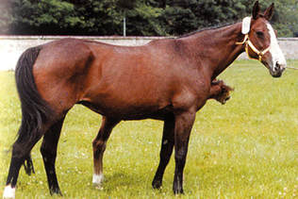
Tangara W SF 1: Foaled in 1963 by Furioso
The mare Tanagra, never produced anything other than good horses including: Danoso (by Night and Day), Escurial (by Night and Day), Geisha N (by Night and Day), Jalisco B (by Alme), Kioto II (by Nykio), Nykias (by Nykio), Oviedo II (by Night and Day) and Ruyblas (by Night and Day).
- Jalisco B 1975 by Alme competed at the Olympics and had numerous Grand Prix wins. He sired 63 approved stallion sons, but the most important has been Quidam de Revel and his sons, Guidam and Nabab de Reve.
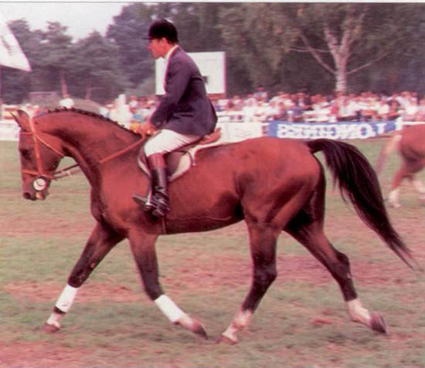
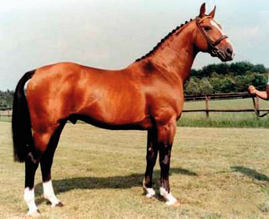
ALMÉ by Ibrahim from Girondine by Ultimate xx 1966-1991 Almé was by the great French stallion, Ibrahim out of Girondine. Almé’s dam, Girondine was a daughter of the Irish bred Thoroughbred, Ultimate, and as well as Almé, she also produced his three full-brothers, all licensed stallions or successful jumpers. Her daughter, La Citadelle (by Jus de Pomme) was bred to Ibrahim to produce three top stallions: Espoir (sold to Spain), Gibramino (sold to Belgium) and Quastor who stood at St-Lô.
The American, Fred Graham purchased Almé at the age of three. He was put into training at Anaud Evain’s stud, Le Cour Bonnet, under the supervision of Captain Gruppelaar. Almé was sometimes ridden by his owner but most of the time by Michel Parot. Almé went on to compete internationally with François Mathy and Johan Heins.
Before he left France for Belgium, he produced the stallion sons, Galoubet, I Love You, and Jalisco, all of whom competed internationally. At the time Almé stood at Zangersheide, the horses bred there were being registered in the Hanoverian studbook, but this did not prevent the Almé genes making their way to Holstein where they were happy to use Ahorn Z (out of the Holstein mare, Heureka) and Aloubé Z and Athlet Z, both out of Hanoverian mares of Gotthard breeding.
In the 2003 edition of Annuaire Monneron, Bernard le Courtois, has this to say about the present influence of Almé, describing him as ‘father of world breeding':
“It is obviously no surprise to see that the line of Ibrahim is influential in French breeding. Almé’s line is becoming increasingly important in many great breeding countries as could be seen during the World Championship in Jerez 2002. I have received from the USA an analysis of the results, which I find interesting and would like to share with you. Among the 92 horses participating, the division between the sexes is relatively well balanced: 32 uncastrated males, not all of them stallions, 34.8%, 31 geldings, 33.7% and 29 mares, 31.5%. Five stallions had more than one product: Quidam de Revel (5), Capitol I (4), Le Tot de Sémilly (3), Robin Z and Touchdown (2 each). Quidam, Robin and Touchdown are grandsons of Almé and 21 horses in the event (22.3%) were descendants of Almé. At the end of the speed class and of the Nations Cup we could count among the Top 25: 10 stallions, 7 geldings and 8 mares; 9 of them came from Almé (36%). When we arrive at the Top 10 (after two rounds of the individual championships) we find ourselves with four stallions, one gelding and four mares, four of them from Almé (40%). The four horses in the final (where the riders swapped horses) comprised one stallion and three mares, three of them from Almé, 75%! If we were to draw some preliminary, hasty, but nonetheless interesting conclusions we might suggest that if we want to produce horses of high quality the best way would be to invest in mares coming from our leader of the dynasty, Almé. One thing is sure and certain, and that is that Almé remains a valuable asset in the pedigrees of our sport horses. And everything comes together when we remember that the best six year old in Europe this year – Mozart des Hayettes – had Almé twice in his pedigree.”
In the 2007-2008 edition of Monneron, Bernard le Courtois, after spending many hours on his computer, produced a list of the top 75 jumping stallions in the world, on the basis of the FEI list of the top 2515 jumping horses in international competition. This survey once again, confirms Almé’s pride of place, for he is responsible for 17 of the 57 leading stallions on the leaderboard. Four of these stallions are by Jalisco, the most important of which is Quidam de Revel, who heads the standings with 48 representatives. Quidam himself already has two of his sons on the leader board, Nabab de Reve and Guidam. Another Jalisco son, Papillon Rouge is ranked equal sixth in the world with 26 winners. Jalisco B, despite his death at a relatively young 19 years of age, is in 30th place on the leaderboard with 10 representatives.
Almé was also influential in Germany and The Netherlands. His grandson, Acord II (by Ahorn Z) is in 13th place with 16 winners. In Holland, Almé’s son, Animo is 19th with 12 winners. Animo’s son, Andiamo Z is ranked 64th with 5 winners.
At the London Olympic Games in 2012, the legacy of Almé and his sire, Ibrahim, was much in evidence.
The list of Olympic showjumping nominations showed 10 progeny by the Almé grand son, Baloubet du Rouet, double the next best tallies – 5 each for Darco and Quick Star. Not all these nominated horses actually made the teams for London, but in a way, I feel the nominations are perhaps a better source of data for the breeding enthusiast than the final teams’ lists, which are perhaps more influenced by the skill of the rider.
The nominations underscore the ongoing importance of the stallion Almé, the grand-sire of Baloubet, although perhaps we should go one generation further back to Almé’s sire Ibrahim, arguably the greatest of all jumping sires, since we see his influence not just through Almé and his sons (particularly Quick Star, Skippy and Jalisco) but also through his other stallion sons, like Fleuri du Manoir, dam sire of Vigo d’Arsouilles, and a relative newcomer, Tangelo van de Zuuthoeve who is by Narcos II whose great grandsire on both his top and bottom lines is Ibrahim, with a further cross of Ibrahim on his dam line, through Almé once again.
The legacy of Almé’s time in Zangersheide continues with his son Ahorn Z, the sire of Acord II, in turn the sire of Arpeggio with three and Acorado I with two and Acacio, Araconit and Atlantic all with one representative.
The other stallion discovered at Zangersheide and spirited away to Holstein by Maas J Hell, Athlet Z, is represented by his son, Adelfos.
Almé’s Dutch family also makes an appearance, with his grandson, Andiamo, via Animo, providing two entries.
Only two stallions managed to put more than one horse into the final top 22 that fought it out for individual honors at London: Baloubet du Rouet sired Rahmannshof Bogeno (dam by the Dutch stallion, Elanville) and Napoli du Ry (out of an Oldenburg mare, by Silvio I). Quick Star had two, Big Star and Star Power with Quick Star’s son, Obos Quality contributing another, Castlefield Eclipse. But really it was a triumph for Almé and his son, Galoubet who sired both of these stallions. Interestingly, both the Quick Star stars bear the KWPN brand. Big Star’s dam is Nimmerdor / Ramiro, a mix of two of the great Holsteiners who came to The Netherlands, while Star Power is out of a Calvados / Le Mexico mare – two influential French imports to Holland.
There was further Almé influence through another son, Jalisco, sire of Quidam de Revel in turn the sire of Dollar de la Pierre, sire of Rebozo. Quidam was also the sire of Nabab de Reve, sire of silver medallist, London.
Nabab is also the dam sire of Hello Sanctos (by the Heartbreaker son, Quasimodo vd Molendreef). Almé also featured in a somewhat more tortuous way in the pedigree of another of the top 22, Temple Road, by Antaeus by Acord II by Ahorn Z – a product of Almé’s stay at Zangersheide.
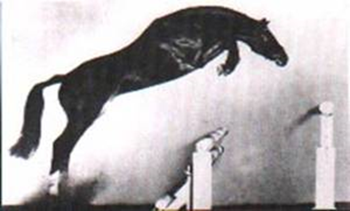
Cor de la Bryère
by Rantzua from Quenotte by Lurioso xx 1968-2000
Cor de la Bryère foaled in 1968, he was a brown stallion, by Rantzua from Quenotte (Lurioso) is one of the most influential sires in modern warmblood warmblood breeding. Cor De La Bryere stood at Siethwende from 1971 to 1984, Zangersheide 1985, Elmshorn 1986 to 1988, Sollwittfeld from 1989 until his death in 2000.
Cor de la Bryère is the stallion that revolutionized jumping horse breeding. His name is the one astute breeders like to see, especially on the mare line, for ‘Corde’ tends to give great form over a jump.
Cor de la Bryère almost missed out on making it to the breeding barn. In 1970, the selection committee of the Haras du Pin visited his owner, Xavier Ribard and suggested ‘that is not breeding stock, he’s too much of a sport horse. Better geld him; he’ll make a useful gelding.’
The horse was now on the market – and it just so happened that the Holstein Association was looking for French blood, having seen the success of Furioso II and Futuro in Oldenburg. Oldenburg breeder (and showjumping ace) Alwin Schockemöhle was looking for a stallion star, and leased the Furioso xx son Urioso – however he was prepared to sub-lease the stallion to the Holstein Verband.
Hence a Holstein inspection committee travelled to France to evaluate Urioso and in doing so discovered Cor de la Bryère. Urioso ended up standing two forgettable seasons in Holstein while ‘Corde’ left an indelible mark on the Holstein breed, and jumping the world over.
He was not only a sire himself, but a sire of sires. The full brothers, Caletto I, II were stars, as were the quintet of brothers, Calypso I to V. In the jumping arena, his handsome grey son, Corrado has been a star for Franke Sloothaak, while Cordalmé Z with Gilbert Böckmann has also been successful at international level. Both went on to become influential sires.
In his first season, Cor de la Bryère covered 70 mares at Siethwende and four colts from his first crop were licensed. He was a stallion of great vigour, and as late as 1977 served a full book of 111 mares.
Although best known as a sire of jumping horses, Cor de la Bryère was also the sire of Corlandus, a World Cup Dressage Champion in 1989, and his sons Calypso I and Calypso II have proven useful sires of dressage horses. Former German Olympic team member, Chacomo ridden by Alexandra Simons de Ridder was by Calypso I, as was Alexandra’s other FEI star, Champus.
In the WBFSH ratings for 1992/2001, Cor de la Bryère is ranked 18th with 28 points earning progeny, but there are a staggering 20 own sons on the rankings: Calando I, II, IV; Caletto I, II; Calvados I, II; Calypso I, II, III; Cantares, Carneval, Carte d’Or, Casanova, Cavalier Royale, Cinzano, Constant, Contact, Corrado I, Cortez 679, Cosinus. There are also 12 grandsons of Cor de la Bryère in the standings – not to mention important stallions like Cathago, Burggraaf and Quantum – who are out of Cor de la Bryère mares.
Romedio Graf von Thun-Hohenstein in his book, The Holsteiner Horse, commenting on Cor de la Bryère’s form over a jump: “When the goal was to join the exciting powerful jumping ability of the Holsteiner with a sophisticated skill, combined with an ideal bascule, sooner or later a stallion such as Cor de la Bryère had to be selected. The arching back, like a taut band of steel combined with the super elastic end gives limitless, but always expedient, springing capability to the natural dynamics of each effort. Add to that ease of riding, marvelous disposition, and a floating, highly balanced canter. These qualities are absolutely to the benefit of young horses, who will no longer have to pay with premature breakdowns caused by jumping and showing solely with a raw, crude jumping talent.”
And perhaps it was a case of a stallion being in the right place at the right time – French equestrian journalist, Bernard le Courtois is firmly convinced, that left in France, Cor de la Bryère would have simply confirmed the original assessment of the French selection committee.
According to Bernard: “Some stallions cross very well in a particular situation. For example, Cor de la Bryère. He was exceptional in the 70s in Holstein because he was a horse that was very quick with the front legs. He did not have the power on the back side, but he was a very electric horse, with the blood of the Thoroughbred, Rantzau, and mixed with the heavy Holsteiner mares, he was fantastic. But when we tried to breed Cor de la Bryère with the French mares, we had rabbits. Cor de la Bryère needed a very strong mare, and we didn’t have this kind of mare in France.”
In the French annual review, Monneron 2007-2008, Bernard le Courtois has gone through the FEI list of the top 2515 best showjumpers to compile a stallion ranking of the top 75 stallions, based on CSI winners. He finds that, after Almé, Cor de la Bryère is the most influential sire. Corde himself still holds 51st place on the rankings with 6 CSI winners – and that 14 of his sons make up 19% of the 75 best stallions in the world.
The most successful of these sons is Corrado I, who occupies 23rd spot with 11 winners – with four sons of Corrado also featuring in the top 75: Corofino is 30th with 10 representatives, Coriano – 43rd with 7, Indorado – 43rd with 7, and Clinton – 64th with 5.
Cor de la Bryère’s influence is also transmitted via the full brothers Caletto I & II. Although Caletto II does not make the top 75, he is represented by his sons, Caretino (24th with 11 winners, sire of Casall) and Calvarro Z (65th with 5). Caletto I himself, is in 65th place with 5 winners, and is represented by his son Cantus (30th with 10). Cantus is the sire of Calido I who is in 19th place with 12 winners.
Another Cor de la Bryère son, Calypso II is well represented on the top 75 through his son, Contender, sitting in 5th with 28 representatives.
There were five representatives of the Cor de la Bryère line in the final of the 2009 European Showjumping Championships, including the silver medallist, Corradina (by Corrado out of a Sandro mare) ridden by Carsten-Otto Nagel.
He is known as the "Reserve Stallion of the Century", second only to Landgraf I. Champion of his 100 day test, he revolutionized jumping horse breeding, He is one of the most important sources of showjumping blood in the world today and one of the most significant Stallions in Holsteiner breeding. He has sired top international jumpers, dessage horses, 49 approved sons, 60 state premium mares. He is one of Germany's top ten eternal sires.
Even today the great French influence on Holstein breeding, the Cor de la Bryere line is presented with 24 decedents competing at the world equestrian games in 2014.
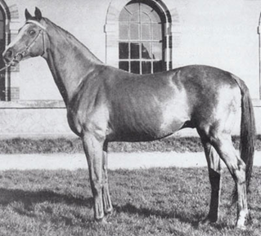
Rantzau by Foxlight from Rancune
Rantzau- By Foxlight from Rancune. Rantzau, was a French Thoroughbred, bred to be a jumper being a descendant of the enormously influential Bay Ronald. Rantzau was by Foxlight by Foxhunter by Foxlaw by Son-In-Law by Dark Ronald by Bay Ronald. A serious racehorse, Rantzau was the third ranked three year old of his year. In nine races between 2000 and 3000 metres, he won two and was placed five times. Purchased by the National Stud, he arrived at the stallion depot of Saint-Lô on January 5th, 1951.
Of Rantzau, the stud inspector noted: ‘good front extension, remarkably built through the shoulder and fore-arm, long haunches, this classy stallion of rare nobility, also has low-placed joints and covers ground.’
Contrary to legend, the breeders in the area were quite enthusiastic about this well-bred, well-conformed and well-performed newcomer, and between 1951 and 1962 he bred between 40 and 49 mares a year. In those days French state stud stallions were only allowed to breed 40 mares a year, plus the National Stud director’s cards used by him ‘in the interest of breeding’. In 1971 he covered his last book of mares, with five foals the result. In twenty years of breeding he covered 772 mares at an average of 38 mares a year for 179 fillies and 194 colts. His fertility of 50% was regarded as normal for the time.
By 1964, Rantzau had moved into 3rd place on the ranking of aged sires of jumping horses, behind Lutteur B and Kenavo D, and the next year he moved into 2nd place with progeny jumping with success all over Europe, and held that second place until 1969. In 1970 he moved down to third place behind Ibrahim and Furioso, but the next year he moved into first place on the jumping rankings, as well as being in 5th place on the sire of eventers rankings – he was even ranking in the 20s as a sire of dressage horses.
As late as 1976, when he had been dead for five years, Rantzau was still 3rd on the jumping sire’s rankings, by 1980 he had moved into 4th place. He remained for many years one of the leading sires of broodmares.

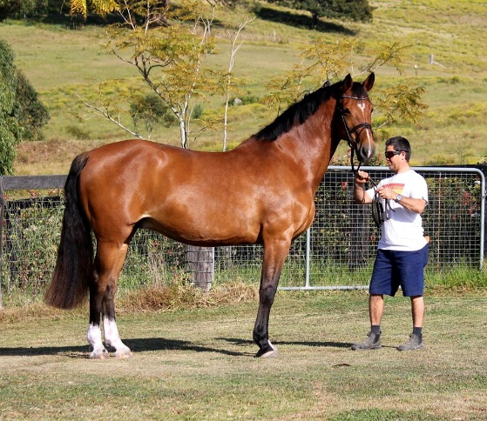
Valenzia by Carinjo from Cayenne by Calypso 1
Cera Quantro’s dam Valenzia is a daughter of successful international showjumping stallion Carinjo (Patrice Delaveau), and descends from a highly successful sports family- Holstein Stamm 242. This mareline has produced World class show jumpers and more than 40 approved stallions, which rank amongst the very best in Holstein. Valenzia's sister Nischa was successful to 1.50m level and produced the Reserve licensing champion Con Cosmos. Valenzia has an approved stallion brother, Barkeeper who was also successful in sport, and two other siblings have been highly successful in showjumping. A half sister to Valencia's dam produced Loro Piana Chiclana who has been successful at the highest level of international showjumping.
Valenzia herself has already produced one of the best young stallions in Europe- L.B. Crumble by Colman, now under Christina Liebherr and is competing at 1.40m, as well as the exciting second season sire Cera Charisma by Casall Ask which has just began his showjumping career with Katie Laurie.
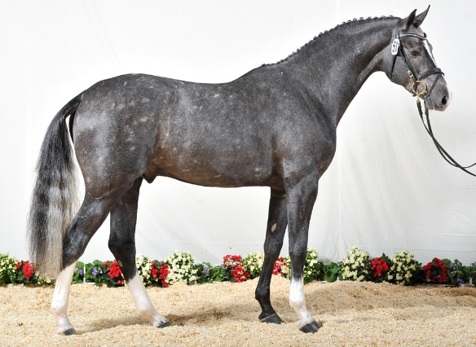
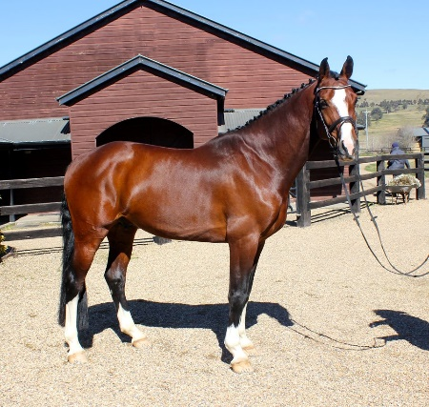
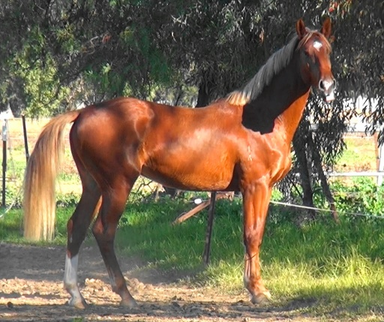

Valenzia

 | Carinjo  HOL-DE/FR-01-B | Cascavelle  HOL-DE-86-GR | Cantus  HOL-DE-81-GR | Caletto I | Cor de la Bryere
 |  |  |  |  | Deka
 |  |  |  | Monoline | Roman
 |  |  |  |  | USA
 |  |  | Phaedra  HOL-DE-78-B | Calando I | Cor de la Bryere
 |  |  |  |  | Furgund
 |  |  |  | Fangelika | Consul
 |  |  |  |  | Rinde
 |  | Exquisite  HOL-DE-90-B | Landgraf I  HOL-DE-66-B | Ladykiller | Sailing Light
 |  |  |  |  | Lone Beech
 |  |  |  | Warthburg | Aldato
 |  |  |  |  | Schneenelke
 |  |  | Grossfürstin  HOL-DE-70-B | Ramiro Z | Raimond
 |  |  |  |  | Valine
 |  |  |  | Vineta | Heidekrug
 |  |  |  |  | Nina
Valenzia BP
 | Cayenne III  HOL-DE-88-BR | Calypso I  HOL-DE-MAR-73-B | Cor de la Bryere  SF-FR-68-DB | Rantzau | Foxlight
 |  |  |  |  | Rancune
 |  |  |  | Quenotte | Lurioso
 |  |  |  |  | Vestale du Bois Margot
 |  |  | Tabelle  HOL-DE-59-BR | Heissporn | Heintze
 |  |  |  |  | Franzi
 |  |  |  | Hyazinthe | Lorentin
 |  |  |  |  | Priamel
 |  | Valenzia  HOL-DE-83-BR | Ladalco  HOL-DE-77-B | Ladykiller | Sailing Light
 |  |  |  |  | Lone Beech
 |  |  |  | Zala | Aldato
 |  |  |  |  | Marietta
 |  |  | Lublin  HOL-DE-74-B | Farnese | Fähnrich
 |  |  |  |  | Annelies
 |  |  |  | Zypresse | Aldato
 |  |  |  |  | Diastolchen

Blood Quota of |  | in five / twelve generations

Generation |  |  | 1 | 2 | 3 | 4 | 5 | 6 | 7 | 8 | 9 | 10 | 11 | 12 |  | Generation |  |  | 1 | 2 | 3 | 4 | 5 | 6 | 7 | 8 | 9 | 10 | 11 | 12
18.8% | 6.3%  12.5% | Cor de la Bryere |  |  | 1 |  | 2 |  |  |  |  |  |  |  |  | 12.5% | 6.3%  6.3% | Ladykiller |  |  |  | 1  1
9.4% | 3.1%  6.3% | Aldato |  |  |  |  | 1  2 |  |  |  |  |  |  |  |  | 7.2% | 3.1%  4.1% | Heintze |  |  |  |  | 1 | 1 |  | 1  1 | 6  3
6.6% | 0.4%  6.3% | Heissporn |  |  |  | 1 |  |  |  | 1 |  |  |  |  |  | 4.7% | 4.7%  0.0% | Consul |  |  |  |  | 1 | 1
3.7% | 0.6%  3.1% | Lorentin |  |  |  |  | 1 |  |  | 1 | 1

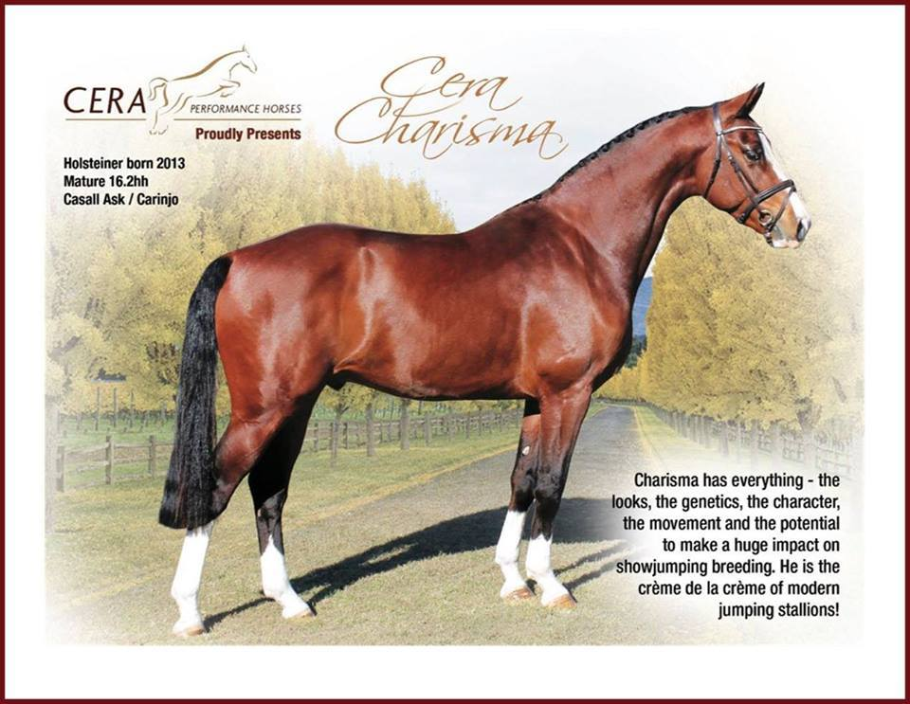
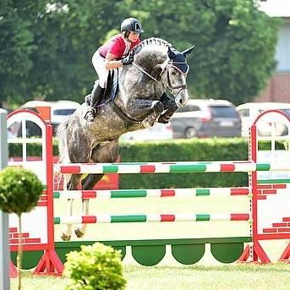
Valenzia has already produced a licensed stallion son, Crumble 2010 (by Colman) who was licensed in Holstein in November 2012 and is also approved in Hannover and Oldenburg. He was the stand out jumper at his licensing, topping his 30 day Stallion Performance test and came 2nd in his 70 day Stallion Performance test, and now is starting his showjumping career. Crumble had a remarkable list of results as a 6 year old including 8 wins last year (2016) at L & M level and is now commencing his international career under Christina Liebherr. Crumbles first season at stud produced the two top priced auction foals, the reserve champion foal of all of Holstein (which is second out of 4,000 foals).
Valencia is also the dam of the exciting second season sire Cera Charisma by Casall Ask which stands at Cera Performance Horses and has started his career with Katie Laurie.

(Ad for Crumble)
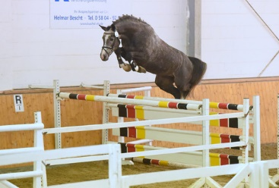
Crumble by Colman from Valencia
2010 168 cm Gray Holsteiner Stallion Colman x Carinjo - Calypso I Breed to an up-and-coming star! This breathtaking young stallion has everything you dream about in breeding and sport: Type, charisma, strength, movement, a perfect pedigree, character and a first-class talent over fences. This performance is not a coincidence -- Colman, Carinjo, Calypso I and Ladalco and their offspring have all gone to the top on an international scale. Crumble's dam is a sister to the approved stallion Bartender. A sister of his mother Valencia (Nischa, S-Level successful competitor) brought Colman the Reserve Champion stallion Con Cosmos. Another brother of the mother is also S-Level and two more are successful at M Level. Power comes packed in the exceptional stamm 242: the stallion Liostro and international jumpers Lady Fairy, Chienos (CO Nagel) and Cathagene (p Ronne v . ) come from Crumbles direct maternal line. Crumble is a stallion with a great future. The highest interior traits and rideability make daily work with him a pleasure. This was also reflected in his 30-day performance test, which he left as expected the Jumper Champion (3x 9.5) with high Ridability and interior values (9.25) . His 70-day HLP in 2014 he finished second overall in a strong group. Crumble again received top marks for his jumping ability. With excitement we welcomed the first crop of foals in 2014 and were not disappointed -- the foals exceeded expectations with foal championship winners, top auction results (up to 20.000, - €) and the Vice - Foal Champion of the Holsteiner Verband. Standing at Hengststation Voelz.

superior Holstein Marelines of Valenzia
Stamm 242: Diastolchen, the founding mare of the Diastolchen branch of Holsteiner stamm 242. Diastolchen produced the stallions Laertes and Anklang, as well as the mare Ulana. Ulana (Anblick xx/Loretto), a full sister to Anklang, went on to produce the Consul son Joost, Mannerheim (v. Rushing Water xx) and the Cromwell son Colt (the sire of Ella from Dorette, making Colt the grand sire of stallions such as VDL Chin-Chin and Quantum) . Ulana’s daughter, Nirza, was a successful driving horse under the name Noblesse before producing the stallion Alcatraz. The Diastolchen daughter Alpenblume produced the mare M Hyazinthe by Ladykiller known for producing excellent performance horses and approved stallions including Ahorn by Nimmerdor, Denver by Nimmerdor and Good Line by Good Times, she introduced stamm 242 to the Netherlands. This branch of the Diastochen line has produced horses like Vdl Bordeaux, Taloubet VDL, Falsterbo VDL, Fontaine VDL (Stands in Australia).
Stamm 162, Fangelika- Thru the daughter Phadra H dam of Cascavelle. Descendant s from this line include Lord Calando, Carthago, Leonce, Abc Charleston.
Stamm 8777- Monoline- thru the son Cantus. Descendants from this line include Calvin z, Lansing
Stamm 703- Nina HSP- Descendants include Carinjo, Rocket Star, Talisman 1, Talisman 11, Landprinz, Landprinz 1, Landprinz 11, Landcolt B.
Stamm 6582- Hyazinthe S thru daughters Salmei H (dam of world champion and Olympic champion in dressage horse Granat) and Tabelle H, dam of the 5 Calypso brothers, Congress as will Askari, Claydon and Casallando decend from this line.
Stamm 318d1- Marietta HSP, the stallion Ladalco by Ladykiller descends from 318d1, other descendants from this line include Ladalco’s full brother Boy 5 an International showjumper ridden by Eddie Macken and World Champion Cavalor Cumano. The stallion Labrador, Little Boy, Casiro 1, Casiro 11.
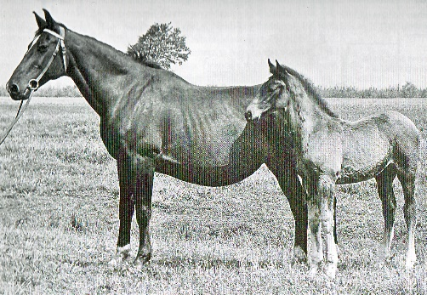
Diastolchen Holstein Stamm 242
Holstein Stamm 242- Diastolchen- 1945 (Loretto x First x Rudolf), the founding mare of the Diastolchen branch of Holsteiner stamm 242. Diastolchen produced the stallions Laertes (Ladykiller) and Anklang (Anblink), as well as the mares Ulana (Anblink), Zypresse (Aldato), Virtus (Anblink), Alpenblume (Fasching), and Biasta (Fasching).

Name | breed | Sex | Dob | Land | Color | Level | Stallion ^ | Mare
Zypresse | HOL | f | 1963 | DE | B |  | Aldato | Diastolchen
Anklang | HOL | s | 1958 | DE | B |  | Anblick | Diastolchen
Ulana | HOL | f | 1960 | DE | BR |  | Anblick | Diastolchen
Virtus | HOL | f | 1961 | DE | BR |  | Anblick | Diastolchen
Alpenblume | HOL | f | 1965 | DE | BR |  | Fasching | Diastolchen
Biasta | HOL | f | 1965 | DE |  |  | Fasching | Diastolchen
Laertes | HOL | s | 1966 | DE | DBR |  | Ladykiller | Diastolchen

The Ulana gave birth to the renowned sires Colt (Holstein Association) and Joost (Netherlands, leased stallion Holstein Association). The great granddam Diastolchen moreover produced the sires Anklang and Laertes. In addition to that, bloodline 242 brought forth the stallions Ahorn Z, Mannerheim and Record (all private stallions Netherlands), Briscar, Lesanto, Liostro, Roderik and Locarno (all private stallions Holstein), Calatus, Castellini, Ravensberg (all private stallions Holstein), Canino de Lobo (private stallion Rhineland, Rhineland-Palatinate-Saar), Lutz L (private stallion Westphalia) and the top international competition horse Rosella G /Ludger Beerbaum.
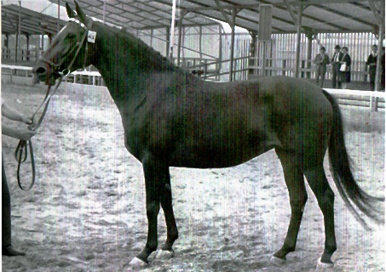
Ulana 1960 (Anblick xx/Loretto x First), produced the renowned stallions Joost (Consul), Colt (Cromwell) and Mannerheim (v. Rushing Water xx), and is furthermore the granddam of the breeding stallion Merano. Colt the sire of Ella from Dorette, making Colt the grand sire of stallions such as VDL Chin-Chin and Quantum) . Ulana’s daughter, Nirza, was a successful driving horse under the name Noblesse before producing the stallions Alcatraz (Aloube Z), Castellini (Contender) and Comet (Caretini).
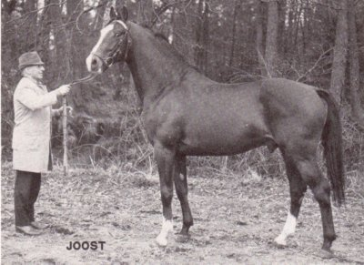
Joost- by Consul (Cottage Son) from Ulana. Joost was licenced as Conus. He was promoted in the Netherlands and become a sire of world- wide recognition. Though his parents, he received a 50% shot of thoroughbred influence from each, creating a combined sucession of equal blood from Cottage Son xx and Anblink xx, which merged excellently together. Joost was back- Leased for several years to rescue this line of the Consul succession, and then produced the stallion Joker, stationed in Hesse, followed by the grey Joliot. From the Netherlands cover use, the stallions Galveston 9private tud Saxony) and Jimmy (Pony breed Holstein) emerged who sired in Germany. 16 daughters are registered in the breeding books of German Associations. The Joost daughter Esmelusiena, is the dam of the highly ranked KWPN stallion Namelus R, Reserve Champion at the 1998 Stallion Show in ’s-Hertogenbosch
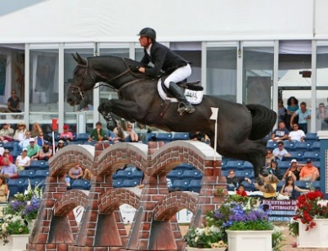
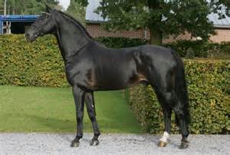
Namelus R -By Concorde from Esmelusiena by Joost. At a young age, Namelus R proved himself as a sire of top athletes with ample "blood," producing offspring such as the Dutch champion Boemerrang, the KWPN champion stallion Arthos R, and the talented PSI horse Nintender. Another renowned Namelus R offspring, Beau Rubertha R, earned the highest score at the 2010 Dutch Mare Performance Test (EPTM) (88 points). Her full brother Dexter R (Namelus R x Contender) was the revelation of the 2011 KWPN Stallion Show.Namelus R offspring excel in international competitions, as evidence by horses such as Upsala, BMC Nathos R, T.Sellie, Tantalus, Monterey, and Triple X III (team gold winner, 2012 London Olympics). Because of his excellence as a sire, Namelus R is approved by several studbooks: the KWPN, Holsteiner Verband, Oldenburg International, Selle Français and Zangersheide.
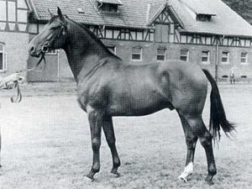
Colt- by Cromwell (Cottage Son) from Ulana. Colt was mid sized, yet Large framed. His foundation was correct, and in consideration of his thoroughbred percentage, it was sufficiently strong. He was certified with first class movement, and good shoulder freedom. Colt had good character and promoted himself well as a performance type through durability and resilience. In only two cover years, he had established himself in breeding. His licenced sons Cento and Coran (private stud Denmark) did not sire in Germany, but Colt daughters become valuable, totalling 16 who were registered. According;y the successful level S, half-brothers Constant and Randers were out of the Colt daughter Ella. Cabinette 1 and 11 also had a Colt dam, and the highly spirited Landcolt B by Landgraf 1, used by Saxony Anhalt. The Colt daughter Essays, dam of the stallion Montanus, was a successful sport horse for many years with Anja Peters. In addition, Colt emerged in the third generation of many well-known stallions, Colt was recognized too late as a performance transmitter.
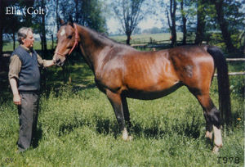
Ella (born 1968, v. Colt from Dorette) produced 10 offspring amongst these are the full siblings Constant, Ulla V and Palisa all by Cor de la Bryere and the stallion La Sauvage by Le Grand 1.
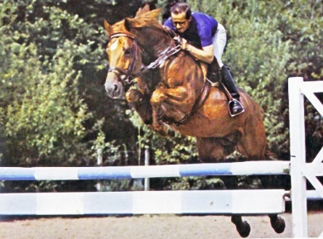
Constant by Cor de la Bryere from Ella- because of his chestnut color Constant was relatively underused and he died at a young age. Constant jumped internationally with Dr. Rüping and Hans-Günther Winkler. His most famous son is Chin Chin, individually 4th at the Olympic Games in Barcelona and the sire of London Individual Silver medalist Glock’s London, Arezzo VDL Triomphe de Muze. Constant as a father of stallion mothers we find him in the pedigree of Campinos, Chacon, Confusion M, Libertino I and II, Ramirado and International jumping gelding Cöster (v. Calato) under Christian Ahlmann.
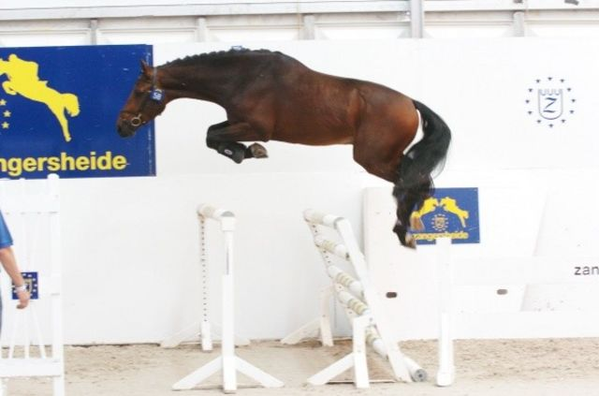
Ulla V by Cor de la Bryere from Ella is a full sister of the stallion Constant. Ulla V is the dam of the Holstein stallion Quantum (Quidam de Revel) reserve champion at his approval and has proved himself as a top class inheritor who unquestionably passes on his quality to his offspring. Quantum’s full sister K-Quintana produced the approved stallion Castar Cooper a son of Caretano. Ulla V’s full sister Palisa, produced 1.60m competitor Queen Liesa, ridden by Felix Hassmann.
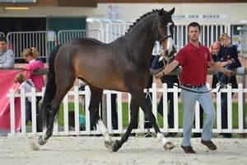

Nirza, by Ronald from Ulana was a successful driving horse under the name Noblesse. Nirza state premium mare produced a number of successful sports horses, including federal championship contestants and top auction horses including the stallion Alcatraz (Aloube Z). The stallions Castellini (Contender) and Comet (Caretini) descend from the Nirza daughter Amanda by Ahorn Z.
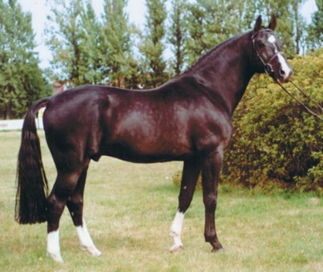
Alcatraz by Aloube Z from Nirza by Ronald from Ulana. Alcatraz was the sovereign winner of the aptitude test for approved and performance tested stallions carried out at the DLG-show in Frankfurt for the first time in 1989. He passed the stallion performance test with top scores for jumping ability and galloping (10 points respectively in training), as well as loose jumping (9.5); In addition to that, he achieved well above average points in all other test criteria (between 7.67 and 9.0), making him the worthy performance test champion.
Alcatraz began a brilliant stud career right from the start. He has presented six approved stallions to date, namely, Aurelio I and II, Alcazaro, Arnstein E, Argent and the 1993 Holstein approvals champion Akinos. He furthermore sired fifteen state premium mares, of which the majority achieved outstanding results at the broodmare performance test in Holstein. His progeny are doing well in competition sport. Apart from conformation class winners and series winners of showjumper classes, he has already presented successful international showjumpers including i.a. Achille Laura, Alcamo 2, the approved Alcazaro and Aurelio II, Apia and Ashley 38). For years now, the FN breeding value rating has listed him at the forefront in respect to his versatile hereditary transmission.

Alpenblume by Fasching from Diastolchen, produced the mare M Hyazinthe by Ladykiller
M Hyazinthe by Ladykiller from Alpenblume is known for producing excellent performance horses and approved stallions including Olympic Ahorn by Nimmerdor, Denver by Nimmerdor and Good Line by Good Times, she introduced the Holstein stamm 242 to the Netherlands. This branch of the Diastochen line has produced horses like Vdl Bordeaux, Taloubet VDL, Falsterbo VDL, Fontaine VDL (Stands in Australia). Caresino, Cantatus B, Locarno, Merano, Lesanto, Arc de Triomphe VDL, and Lancier.
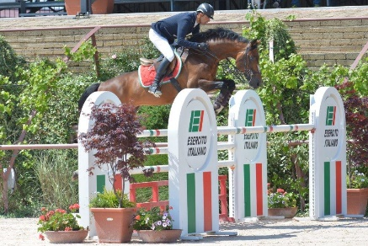
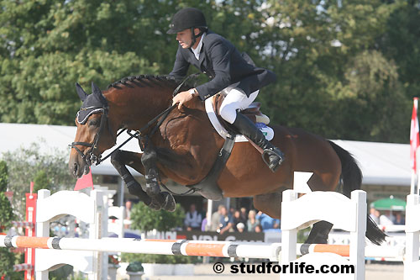
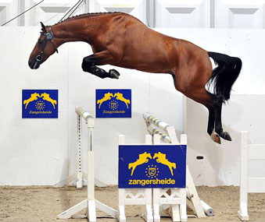

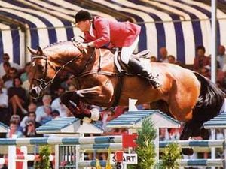
Oylmpic Ahorn by Nimmerdor from M Hyasinthe. Olympic, Preferent Ahorn descends from the famous Holstein family 242, and is related to Joost, Alcatraz and Locarno. His mother produced 4 approved stallions, and so far, 3 international showjumpers. Ahorn competed at the top international level, consistently placing in World Cups and Grand Prix competition. He represented the Netherlands in Nation's Cup competitions and was short-listed for the Barcelona Olympics, which earned him the prefix ¨Olympic¨.
Ahorn's offspring perpetuate their sire's success, with a large number competing at international level. Ian Millar's Grand Prix jumper, Promise Me's damsire is also Olympic Ahorn. Olympic Ahorn is also the sire of Feizal (Mario Deslauriers), Eurocommerce Geneve (10th at the 200d World Cup Final) and Iron, who represented Italy in the 2000 Olympic games.
Ahorn is a fantastic producer of broodmares. He is the sire of European Champion mare Helena, reserve European Champion Korenbloem, Dutch Champion mare Haciende, Firette who was a 5-time UTV qualifier, and Geminka keur who is the dam of Dutch dressage star Kelvin. At the 1996 World Championships for young horses at Lanaken, Ahorn was the only KWPN stallion to have two progeny placed. He is also the sire of Neckar, the top priced horse at the 1998 Equilibra Challenge auction.
As well as top competition horses, Ahorn has produced 8 graded sons. In recognition of his outstanding contribution to Dutch breeding, Ahorn has been awarded ‘Preferent’ status.
Zypresse by Aldato from Diastolchen- produced 3 daughters Dahlie by Hetman and Lublin by Farnese and Lady Fee successful in sport with Sabine Voss (Dressur) and approved son Liostro. The Zypresse branch of Diastolchen has produced Licenced stallions, State premium mares and numerous 1.50m-1.60 competition horses like. Chienos (1.60m), Roxette (1.60m), Chamisso (1.60m) Challenger (1.50m) Coster (1.60) Contano (1.60m) Lady Macbeth DH (1.60m) United Love HDC (1.60) Cinba (1.60) Chiclana (1.60)
Lady Fee by ladykiller was a state premium mare was successful in grandprix dressage with Sabine Voss (Dressur)
Dahlie by Hetman from Zypresse, was a state premium mare and produced 3 daughters Rayon by Fantast, Kategorie by Grandioso and Tugend by Ladalco.
Kategorie by Grandioso from Dahlie produced15 offspring, of these two jumped 1.60 level and least two at 1.50 level. Daughters of Kategorie are also producing horse that jump 1.40 and higher.
Pinie 1 by Mephisto from Katiegorie was a state premium mare and produced the approved stallion Lavendel by Ladalco.
Merano 79 (Male) by Mephisto from Katiegorie jumped at 1.50 level.
Dolores 9 Roxette by Renomee from Katiegorie produced Aristo Z jumped 1.60m
Chamisso (male) by Capitano from Kategorie jumped 1.60 level.
Undine , by Capitano from Kategorie produced K-Camee by Calido, which In turn produced the mare Tana Romana P by Askari which jumped 1.40.
Lienos by Ladalco out of Katiegorie jumped 1.50 level.
Elina 11 by Lavall from Katiegorie was a State premium mare, and produced international showjumping horses, her first son Challenger by Carthago competed at 1.50 level. The mare Navajo by Concerto out of Elina 11 jumped 1.40 level, as well as the approved Holsteiner stallion Caitano by Carthago which competes at 1.50 level. Ulina x111 by Cassini 1 competes 1.35, Contino by Contender competes 1.45, Contano by Contender competes 1.35.
Fee V by Lavall from Katiegorie is also a state Premium mare, produced the Cassini 11 stallion Clovis also known as Castellano. The competition horses Cappccino by Carthago 1.40m, Ma Cherie by Conello 1.45m.
Carluccio by Carthago from Katiegorie was six year old champion of the Bundeschampionat.
Jule 11 by Joliot from Katiegorie produced Sternchen by Limbus which competes at 1.40 level. Chienos by Chamonix was the last foal from Kategorie, he competed at 1.60 level.
Annakonda 11- foaled 1986 by Renomee from Katiegorie produced the mares Nadina by Cash and Farina XI by Landgraf 1, Goldika V1 by Carthago, Havina by Carthago, I-Lavinia by Lavall 1, Lukrezia by Coriano, Nadina 1 by Cash, Chapter One by Chilento, Avalon by Aljano
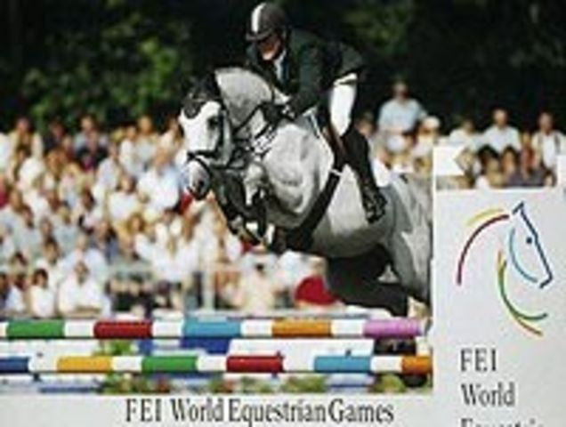
Farina XI by Landgraf 1 from Annakonda 11 became a state premium mare. Farina’s first foal Kartuschka by Carthago was known in sport as Charlottenhof’s Carthagena, she jumped internationally at 1.40 level and produced Coster by Calido which Won the 6 year old jumping Ch. at 2004 German Bundeschampionat. Sold at PSI Auction for €700,000. Approved stallion Condretto by Contender.
Goldika V1 by Carthago from Annakonda 11 produced Casillia by Casall jumped 1.50m, approved son Contano by Contendro11 competing 1.60 level in France, Lady Sunshine by Limbus state premium mare which sold at auction for 160,000 euro
Lanzelot by Lavaletto from Annakonda 11 jumped at 1.40 level
Havina by Carthago from Annakonda 11 produced Lady Macbeth DH by Limbus which competes at 1.60 level, Quantero 2 by Quantum jumped 1.45m. Luckt 394 jumped 1.45m
1-Lavinia by Lavall from Annakonda 11 produced 4 stallions Carlussio by Capitol 1, Caprisio by Carpaccio competed 1.45m and Catall by Catoki, Camvall by Cambridge as well as the competition mare United Love HDC, jumped 1.60 and is the dam of the young stallion Casparon by Berlin.
Lukrezia by Coriano from Annaconda 11 competed at 1.35 level
Nadina 1 by Cash from Annakonda 11 is owned by Haras de la Vie and is producing several high quality offspring.
Rayon by Fantast from Dahlie produced Ravaella by Levantos 1 which jumped 1.50m, horses such as Colmino by Colman jumped 1.50m, Naomi 178 1.40m decend from the Rayon line of stamm 242.
Tugend by Ladalco from Dahlia produced Z-Mallendina by Marlando jumped 1.40, also the 1.60 competitor Cinba by Con Capital descends from the Tugend line of Stamm 242.
Lublin by Farnese from Zypresse- Produced the stallion Liostro by Ladykiller and the mares Valenzia HSP by Ladalco, Ticila by Ladalco and Bienerin by Konigspark.

Valenzia HSP by Ladalco from Zypresse was a state premium mare produced 2 daughters Cayenne11 by Calypso 1 and F-Liberia by Lavell 1.
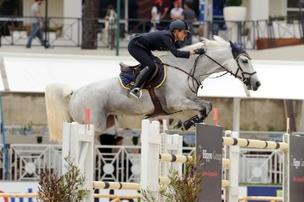
F-Liberia by Lavell 1 from Valenzia HSP is also a special mare her first foal Caramba by Carthago1.50 level, her second foal Casall by Cascavelle jumped at 1.50 level. The mare Chiclana 4 by Cascavelle is registered in Holstein as Paulina 1, she has competed at the highest level 1.60m.
Cayenne 11 by Calypso 1 from Valenzia HSP produced the approved stallion Barkeeper by Barnaul. Cayenne also produced the the 1.45 jumper Little Joe by Landaris, his half sister Nischa by Cascavelle jumped at 1.40 level and produced the Holsteiner approved stallion Con Cosmos by Colman. Cayenne 11 is also the the dam of Valencia 1 by Carinjo
Nischa by Cascavelle from Cayenne 11- was successful to 1.50 level and produced the Reserve licensing champion Stallion Con Cosmos.
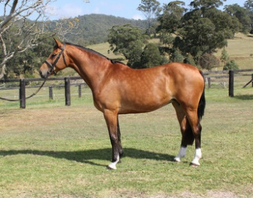
Barkeeper by Barnaul from Cayenne 11 is successful in sport and an approved stallion.
Valenzia BP by Carinjo from Cayenne 11 produced a licensed stallion Crumble 2010 (by Colman), and stallions standing in Australia Cera Charisma by Casall, Cera Quantro by Quantum and mares Cera Chiraz by Colman, Cera Distinction by Diarado, and 2016 Filly by Clearway.
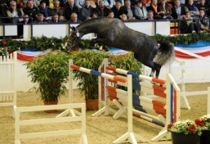
Crumble (by Colman from Valencia BP) who was licensed in Holstein in November 2012 and is also approved in Hannover and Oldenburg. He was the stand out jumper at his licensing, topping his 30 day Stallion Performance test and came 2nd in his 70 day Stallion Performance test, and now is starting his showjumping career. Crumble had a remarkable list of results as a 6 year old including 8 wins last year (2016) at L & M level and is now commencing his international career under Christina Liebherr. Crumbles first season at stud produced the two top priced auction foals, the reserve champion foal of all of Holstein (which is second out of 4,000 foals).
Cera Charisma by Casall from Valenzia BP will stand in Australia for his first season in 2016 with Cera Performance Horses
Cera Quantro by Quantum from Valenzia BP will stand in Australia for his first season in 2017 with Valentine Lodge Performance Horses.
Cera Chiraz by Colman from Valenzia BP produced the colt Cera Quantero by Quantum.
Cera Diara by Diarado produced a Quantum Colt.
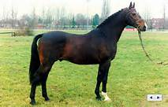
Bienerin by Konigspark from Lublin, her first daughter Fera by Carthago, produced the mare Nastasia 1 by Heraldik xx, who produced Uganda X1V by Caretino, which competed in Mexico and is owned by La Silla. Nastasia’s son Carlinos by Caretino is jumping at 1.40 level, Z-Nessy by Nekton was champion mare of her region. Bienerin also produced Icicle by Mytens xx, which produced All My Choice by Aljano which is successful in Eventing
Liostro by LadyKiller from Zypresse- is the last approved son of the legendary thoroughbred sire Ladykiller xx Liostro conducts the valuable performance Holsteiner blood of stamm 242, the well known motherstamm of Joost, Colt, Laertes and Alcatraz, this dam line has produced over 50 main stud book mares and several premium mares.
Liostro was a beautifully designed halfblood with charismatic presence, he was light footed and elegant in motion. Liostro demonstrated significant ability at the jump. 85 daughters are registered in the breeding books of German associations, five are state premium mares. Liostro’s offspring are very elegant with above average movement, tremendous jumping ability and good technique. He produced several approved stallions including: Larso 1990, Lascall 1990, Lazer 1993, Levantos 1 1990, Lavirco 1995, Leviano 1994, Lavantos 11, Liocaylon 1992.
Liostro also produced over 100 successful sport horses including the Grand Prix winners Otis (Eliza Shuford), LioCalyon (International show jumper with Lu Thomas) and Sapphire (Mark Wattring) who was also the Pan American Games Individual Gold Medal Winner and 2004 Olympian. The international jumping stallion Cagliostro (Calando I) with which Noora Penttii took part in the WK in Aachen 2006 has been bred from a daughter of Liostro. Liostro was the leading producer of money winners in the United States in 2002 and was ranked 9th in the USEF Leading Jumper.
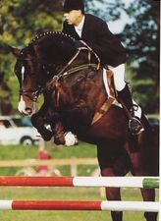
Levantos I by Liostro from Andra 11, was the reserve champion of the Holstien Stallion Licencing in 1992. He is an amazing sire prototype, who had the best type values combined with the gaits of a speaical class and high class jumping values. Levantos I's colt, Leeraner, was the highest priced foal in all of the 1996 association auctions, placing his sire at the centre of attention in various breeding areas. Throughout the years, many of his sons were approved in his Holstein homeland (e.g. Leviano, Lesiano, Lavirco). In 1999, his son, Lichtenau, won the approval in Sachsen and Thringen. He was present in Oldenburg as well with his sons Love and Jump and Levantino H. In the year 2001, his son, Levaro, was the Reserve Champion of the approval in Hesse. His offspring have demonstrated their talents in sports and have been very successful, especially in show jumping. The FN breeding value assessment 2001 ranks Levantos I as one of the most versatile sires.
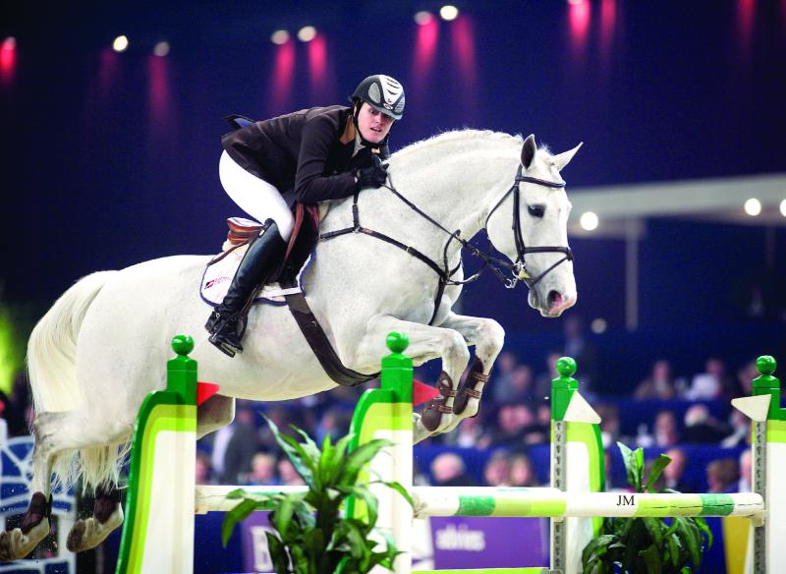
Levantos 11 by Liostro from Andra 11, Levantos II conducts the valuable performance Holsteiner blood of stamm 242 by means of its father Liostro (Ladykiller xx), the well known motherstamm of Joost, Colt, Laertes and Alcatraz. On mothers side Levantos II conducts the valuable jumping blood of the incredible Cantus which we know as a father of the well known jumpers Calvaro V, Come On, Candaletto and Cantus W. Mother Andra II also brought the full brother his except Levantos II, Levantos I, reserve champion of the Holsteiner jumping testing in 1992. Levantos II mother line is registered in Holstein as stamm 4705. Grandmother Gilda (Meteor xx) stands at the basis of a range of approved stallions among which Catoki (Cambridge), Chalan (Chambertin), Larso (Liostro), Laurenz (Lord), Orleandro (Oglio xx), Racord (Rasso) and Rocadero (Ronald). Levantos 11 had an enormous presence, and a correct foundation combined with an exceptional execution of moment. Levantos 11 was reserve champion in 1993, during the Holsteiner jumping test in Neumünster. One year later Levantos II was again runner up at the stallion test at Neustadt/Dosse. The successful sport career of Levantos II started with a second place with the five-year-old jumpers at the Bundeschampionat in Warendorf. Then Levantos II was sold for the astronomic amount of DM 3.000.000 to a Swedish syndicate. Under the saddle of Malin Baryard, Peder Fredrickson and Giovanni Magaton Levantos II performed many years at the highest level in the jumping sport from 1998 up to 2006 with good results in Helsinki, Linz, Goteborg, nag, Aarhus and Falsterbo.
His offspring have proven their talent in sports, particularly in jumping. The national jumpers Miss Fizz M. (Camilla Enemark), Levina (Thomas Patt), Lugano (Christian Heck) and Lambado (Aleksandra Lusina) are four decsendants from the first years of Levantos II breeding that perform at national level in jumping. Approved stallion Lou Bega made furore in international jumping with Juraj Hanulay. The FN breeding value estimation has identified Levantos 11 as one of the best German showjumping transmitters.
Holstein Stamm 242
Ahorn, B., * NL 82, v. Nimmerdor u. Hyazinthe v. Ladykiller xx u. Alpenblume v. Fasching, PB NL; internat. Spr. erf. mit Rob Ehrens (NL)
Ako, B., * Holst. 94, v. Acord II u. E-Laura v. Laurin-Landmeister, PB LAT
Alcatraz, R., * Holst. 85, v. Aloubé Z u. Nirza v. Ronald u. Ulana v. Anblick xx, Holst. Verb., HLP-Sieger
Anklang, B., * Holst. 58, v. Anblick xx u. Diastolchen v. Loretto-First, Holst. Verb.
Barkeeper, B., * Holst. 94, v. Barnaul xx u. Cayenne III v. Calypso I-Ladalco, PB Hess.
Bordeaux VDL, B., * NL 2001, v. Baloubet du Rouet u. Notre Dame v. Silvio II-Nimmerdor, PB NL
Briscar, Sch., * Holst. 93, v. Bachus u. Dancing Queen v. Cor de la Bryère-Landgraf I, Holst. Verb.
Caesario, B., * Holst. 97, v. Caretino u. Valentina II v. Merano-Ladykiller xx, PB Westf.
Caitano, Sch., * Holst. 2000, v. Carthago u. Elina II v. Lavall I-Grandioso, LH Ldg. Neustadt/D., PB Oldbg.
Calatus, Db., * Holst. 93, v. Cantus u. Dulva v. Landgraf I-Ladalco, PB Holst., USA
Canino de Lobo, B., * Holst. 87, v. Caletto I u. Talinn v. Ladalco-Ganeff, PB Rhld., Rhpfs., Holst.
Cantatus B, Sch., * NL 93, v. Cantus u. Gyazinthe v. Belfalas xx-Ladykiller xx, PB Bay.
Capt‘n Incident, B., * Bay. 91, v. Captain Incipit u. Perrit v. Romino-Ladykiller xx, PB Bay.
Castellini, B., * Holst. 95, v. Contender u. Farina XIV v. Landgraf I-Ahorn Z, PB Holst.
Chronik JMEN, B., * Holst. 95, v. Contender u. Aronny v. Renomee Z-Mephisto, PB BRA
Clovis, Sch., * Holst. 2003, v. Cassini II u. Fee V v. Lavall I-Grandioso, PB BEL
Colt, B., * Holst. 64, v. Cromwell u. Ulana v. Anblick xx u. Diastolchen v. Loretto, Holst. Verb.
Cometto, B., * Holst. 98, v. Caretino u. Farina XIV v. Landgraf I-Ahorn Z, PB NL
Con Cosmos, Sch., * Holst. 2003, v. Colman u. Nischa v. Cascavelle-Calypso I, PB CZE
Conus-Joost, B., * Holst. 68, v. Consul u. Ulana v. Anblick xx u. Diastolchen v. Loretto, PB NL, LH Holst. Verb.
Corso FF, Sch., * SUI 94, v. Coeur de Nuit u. Coco Chanel III v. Capitol I-Farnese, PB SUI
Cosimo, B., * Holst. 99, v. Contender u. Farah X v. Silvester-Mephisto, Holst. Verb.
Coster, Sch., * Holst. 99, v. Calido I u. Kartuschka G v. Carthago-Landgraf I, Ldb. Celle, Bundeschampion
Denver, B., * NL 85, v. Nimmerdor u. Hyazinthe v. Ladykiller xx-Fasching, PB BEL, HLP-Sieger
Good Line, B., * NL 92, v. Goodtimes u. Hyazinthe v. Ladykiller xx-Fasching, PB Brdbg.
Laertes, B., * Holst. 66, v. Ladykiller xx u. Diastolchen v. Loretto-First, Holst. Verb., PB Bawue.
Laurin Holstein, Sch., * Holst. 89, v. Laurin u. Zarah v. Rebel Z I-Mephisto, PB NL, USA
Lavendel, B., * Holst. 82, v. Ladalco u. Pinie v. Mephisto-Grandioso, PB Holst.
Lesanto, B., * Holst. 88, v. Landgraf I u. Ulara v. Capitol I-Merlin, Holst. Verb.
Linox, B., * Bay. 97, v. Lord Incipit u. Power Girl v. Captain Incipit-Romino, PB Bay., Ldb. Schwaiganger
Liostro, B., * Holst. 80, v. Ladykiller xx u. Lublin v. Farnese u. Zypresse v. Aldato, Holst. Verb., PB NL, Oldbg.
Locarno, B., * Holst. 72, v. Ladykiller xx u. Cedelle v. Ganeff u. Seenixe v. Fähnrich, Holst. Verb., PB DK
Lutz, B., * Holst. 86, v. Lombard u. Sweety v. Sacramento xx u. Heika v. Heidekrug, PB Westf., AUT
Mannerheim, B., * Holst. 71, v. Rushing Water xx u. Ulana v. Anblick xx-Loretto, PB NL
Mefiszto, B., * Holst. 79, v. Mephisto u. Maibraut v. Landgraf I u. Cedelle v. Ganeff, HUN
Merano, Db., * Holst. 73, v. Merlin u. Berolina v. Fasching u. Ulana v. Anblick xx, Holst. Verb., USA
Miltiades, F., * Holst. 36, v. Mirza u. Philippine v. Rudolf-Rotbart, PB Holst.
Rash R, B., * Holst. 98, v. Cash u. Zarah v. Rebel Z I-Mephisto, PB NL
Ravensberg, B., * Holst. 70, v. Rushing Water xx u. Crassy v. Fasching u. Ulana v. Anblick xx, PB Holst., NL (Lancier)
Record, B., * NL 75, v. Komeet u. Mulana v. Rushing Water xx-Fasching, PB NL
Roderik, Sch., * Holst. 85, v. Renomee Z u. Hellebarde v. Landgraf I u. Cedelle v. Ganeff, Holst. Verb., SWE
Sandeman, B., * SUI 94, v. Sandro u. Fortunata v. Fernando-Cardinal, PB SUI, unfruchtbar
Turijn, B., * NL 77, v. Rigoletto u. Oelana v. Watteau xx-Fasching, PB NL
außerdem die international erf. Sportpferde
Lady Fee (v. Ladykiller xx u. Zypresse v. Aldato-Loretto) Sabine Voss (Dressur)
Caresino (v. Caretino u. Athena VIII v. Silvester-Masetto-Raimond) Hauke Luther
Carthagena (alias Kartuschka G; Mutter zu Coster) Sören von Rönne
Chienos (v. Chamonix u. Kategorie v. Grandioso-Hetman-Aldato-Loretto) Carsten-Otto Nagel
Heika (v. Heidekrug u. Markise v. Dorilas-Loretto) Christa Gössing
Rosella G (v. Ramiro u. Sweety v. Sacramento xx-Heidekrug) Lutz Gössing, Ludger Beerbaum (Springen)
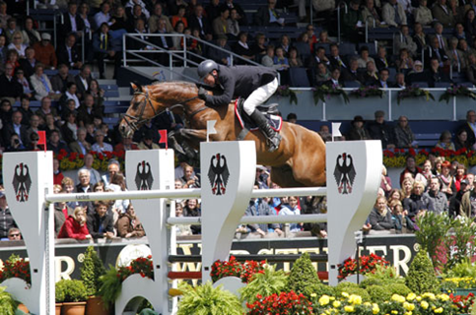
CARINJO by Cascavelle from Exquistite by Landgraf 1
Foaled in 2001 - Holstein –Stamm 703.
Approved for: Holstein, Oldenburg, Hannover, Italy, Denmark, and Baden-Württemberg
Carinjo’s dam Exquisite also produced Perfect lady I, which is the dam of the stallion Conner by Contender. His grandam Grossfurstin also produced Zera dam of Quincy B, winner in CSIO with Hillary Dobbs.

The sire of Valenzia has been described as a jumper for the most important championships - he simply combines everything a good horse needs. Carinjo Initially under Thomas Voss has received winnings and placings at international championships and jumping World Cups like e.g. Steinhagen, Donaueschingen, Lanaaken, Spangenberg, Domek, Kiel, Herning, Neumünster and many more. At the World Cup Championship in Domek Carinjo won three jumping classes, among them the Grand Prix S *. Now ridden by Patrice Delaveau, the pair have notched up plenty of wins at 1.60m level including the CSI5* Longines Los Angeles Masters and CSI5* Grand Prix's wins in Chantilly, Saut Hermes, Antwerp, Bordeau, Oslo, La Baule, St Tropez, Stuttgart and Doha. In 2012 Carinjo came 2nd in the Aachen Grand Prix, and travelled as a substitute horse to the Olympic Games at London.
The champion stallion of 2003 has a big number of state premium mares, great sports horses and approved stallions such as Carin, Carpino, Cariletto, Chitaro, Coral Beach and Criffindor. Carinjo passes on a great heritage paired with perfect technique and a Perfect bascule. In the FN - breeding commission Carinjo made it into the best 5% of stallions in Germany on his first try - thanks to the success of his foals. Furthermore he is placed 4th most successful sport horse in Germany. His progeny is just like him, they are successful at different championships at European level
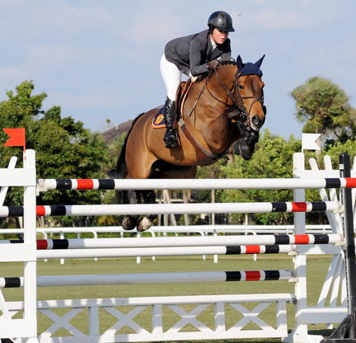
nina hsp Holstein Stamm 703
Carinjo’s mareline, Holstein stamm 703 has produced over twenty stallions including Bachus, very good winner in CSI / CSIO with Jos Lansink and the performer Eurocommerce Monaco, in CSIO with Gerco Schröder and Quincy B, winner in CSIO with Hillary Dobbs. Approved stallions include Carinjo, Rocket Star, Talisman 1, Talisman 11, Landprinz, Landprinz 1, Landprinz 11, Landcolt B.
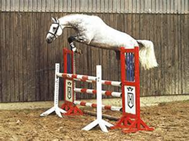
CAscavelle by Cantus from Phaedra by Calando I
Cascavelle has an interesting pedigree, he is by the super jumper sire Cantus who produced Willi Mellinger's great grey 'Calvaro V' winner of individual silver at Atlanta Olympics '96 and team silver at Sydney Olympics 2000, 3rd individually at the European Championships St Gallen '95 and 4th individually at the World Championships Rome '98 etc..... Cantus also gave us the stallions and international GP winners 'Canturo' (Bernardo Alves) and 'Come On' (Ralf Schneider) and the top stallion 'Calido I' etc..
Cascavelle has 'Cor de la Bryere' and 'Consul' doubled in his pedigree, (Deka is also by Consul) this fact can only be a help to jumper breeding....... He comes from a very successful dams line, his mother 'Phaedra is a 3 parts sister to the mare 'Perra' who is dam to none other than 'Carthago' (who with Jos Lansink was a top GP and Championship jumper and now a leading sire) and 'Lord Calando' (sire of the GP jumper and good sire 'Lux Z' and dams sire of 'Numero Uno').
Cascavelle didn’t go into sport instead he went directly to the breeding shed on completion of his stallion test. Where he has produced a number of progeny competing in the international jumping rings, these include:
- 'Carinjo 9' (Patrice Delaveau) at 5 star level he won the GP Barcelona CSIO, a 1m55 at Doha, 1m50s at Gijon, Chantilly & Stuttgart, was 2nd in GP at Lausanne, 4th GP Hang Kong & 6th GP Gijon and previously under Thomas Voss was 2nd in the 5 star GP of Aachen CSIO, won a 1m50 class at 5 star Stuttgart and 1m45 class at 5 star Vienna, won the Nations Cups at 5 star Rotterdam and Falsterbo and the 4 star GP of Chenyakhousk and the 3 star GP of Donetsk.
- 'Cantano' (Meredith Michaels Beerbaum) winner of 1m50 classes at the 5 star shows of both St Gallen and Wellington, winner of a 1m45 class at 3 star Wellington, placed 2nd in the 3 star GP of Spangenberg and 6th in a 2 star GP at Wellington all in 2012.
- 'Casco' (Gerald Geessink) winner of a 1m50 class at 4 star Maastricht in '07, 2nd in the 2 star GP of Neustadt-Dosse, 4th in the 3 star GP of Nantes and 6th in a 1m50 class at 5 star Rotterdam CSIO in 2008.
- Chiclana' (Giulia Martinengo Marquet) winner of 1m50 classes at both the 5 star shows of Rome CSIO and Valencia, also 12th in the GP at Rome CSIO and 3rd in a 1m55 at Valencia and also finished 3rd in a 1m55 class at 5 star San Patrignano all in 2012.
- New Jersey' (Wim Schroeder) multiple winner of 1m40-1m45 classes and multiple top placings at 2 star GP level.
Cascavelle daughters are also proving to be good broodmares and he is dam sire to the top GP horse 'Carlo' (Nick Skelton and Sergio Alvares Moya) multiple 5 star GP winner and bronze medalist individually at European Championships of Madrid in 2011.

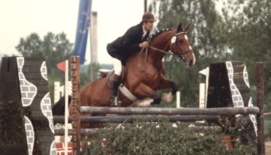
Fangelika Holstein Stamm 162
Is one of the best family’s in jumping breeding - Stamm 162. Of the Worlds best jumping families, 13 motherlines have their origins in Holstein and stamm 162 is ranked second. This ranking is based on the research of Jac Remijnse done from October 1, 2005 through September 30, 2012, using the top 300 jumpers in the WBFSH rankings.
This stamm 162 was started with the mare Ahne5111 by Godophin in 1848 with the family Eggers from Karolinenkoog. Walter Eggers sold the Rinde by Galapeter to Erhard Krampitz. Rinde is the mother of Fangelika by Consul. Fangelika produced the mares Kerrin by and Phaedra by Calando 1.
- Phaedra by Calando 1, produced the Holsteiner approved stallion Cascavelle by Cantus.
- Kerrin by Manbo 1 unfortunately only produced one foal and that was the outstanding mare Perra by Calando 1.
- Perra produced three approved stallions; Lord Calando by Lord, Carthago Z by Capitol and Leonce by Limbus. Daughters of Perra include Werra and A Cover Girl.
- Werra by Corporal daughter of Perra produced ABC Charleston by Capitol 1 (1.60m), ABC Charley (1.40m) and two other offspring at 1.40 level.
- Lord Calando is the sire of successful stallion Lux Z, and international dressage and jumping horse Lacantus.
- A Cover Girl by Capitol 1 jumped at 1.40 level and is the dam of international showjumper Lactic by Landjonker. Candyman by Capitol 1 jumped at 1.50m level
- Diamond Lady by Lord a State Premium Mare. Her daughter My Girl 111 by La Zarras is the dam of Cumthago by Cumano, which is one of the most popular stallions in Belgium, and Guintero C by Quintero is also approved for the BWP.
- Belmondo by Briscar jumped at S Level.
- Cliqout by Caretino performed S Dressage.
- Carthago by Capitol is Perra’s most famous offspring competed at two Olympic Games, and numerous major Grand Prix Classes around the world. He is also an outstanding sire.
- Cinnamon by Corrado 11, jumped at 1.40 level and is approved in Austria.
- Leonce by Limbus is Approved in Holstein, he always stood in the shadow of his two famous hald brothers, but he still produced approved stallions and has produce some very good sport horses.

Ulika by Caletto11 from Fangelika jumped at 1.60 level and produced
- Tulika by Carthago is the dam of approved stallion Clarissimo by Clarimo.
- Voigtsdorfs Quonschbob by Querlybet Hero, successful stallion jumping 1.50m level.
- Chiletto by Carthago competes 1.50 level.
- Starfly by Carthago
- Little Kimba by Clinton 1 jumped at 1.50 level.

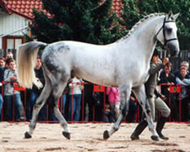
CAntus by Caletto 1 from Monoline by Roman
Cantus was from Caletto I’s first crop in Holstein. His dam, Monoline was by the tough competitor, Roman (Ramzes from Dorette) and out of an advanced showjumping mare, USA. Monoline descends from the Holstein Stamm 8777 and is also the dam of the stallions Calvin Z and Lansing.
Cantus sired many international jumpers incuding:
- Calvaro with Willie Mellinger, winners of the Silver Medal at the Olympic Games of Sydney in 2000.
- Come On who is ridden by Ralpf Schneider and the pair are among the best in German Showjumping, winning Grand Prix and Nations Cups. Come On and Candaletto were Champion and Reserve Champion respectively in the 1994 German Championships.
In 2004 Cantus’ progeny had winnings of €1.35 million.
Cantus had 28 licensed sons including Cascavelle, Calido I & II, Levantos I & II, Cassius Clay (1992 Viernheim champion stallion), Colbert GTI, Canaletto (both private stallions in Holstein), Cyrano (private stallion Hesse) and Cellestial (private stallion Oldenburg).
According to Thomas Mohr, manager of the Maas J Hell stallion station, where Cantus stood:
“Cantus was for 15 years one of the most successful showjumping sires – with horses like Calvaro with Willi Melliger. The horses by Cantus were very powerful and easy to ride, sometimes not the prettiest horses, but very willing to perform.”
Cantus was a very tall stallion at 16.3H with enormous presence. He had good stallion expression and heavy neck. Cantus was a very sharp jumper and a very good mover.
Cantus crossed best with mares with a lot of TB blood. He consistently passed on his jumping ability.
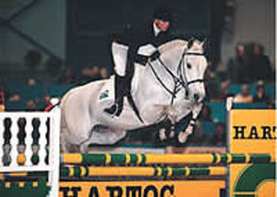
Monoline Holstein Stamm 8777
Monoline 1975 by Roman (Ramzes from Dorette) from the advanced showjumping mare USA. Monoline was by the tough competitor, and dam of superstar stallions Calvin Z, Cantus, Lansing and the mare U-Laester.

- Calvin Z by Caletto 11 has produced world champions at both age group levels, International Grand Prix horses and a tremendous broodmare sire.
- Cantus by Caletto 11 a exceptional progenitor sired the legendary showjumping gold medallist winner, Calvaro V and the stallions Come On, Callido 1, Callido 11 and Cascavel.
- Lansing is an international Grand Prix showjumper and taken to victory with Bo Kristofferson as a five year old winning the prestigious Bundeschampionart (German National Showjumping Championships). He has produced world champions at both age groups and Grand Prix level.
- U-Laester by Lagos is the grandam of the stallion Alicante by Casall Ask.

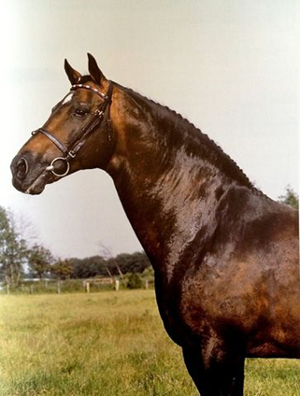
Landgraf 1 by Ladykiller xx from Warthburg by Altato
Landgraf 1 foaled in 1966 by the Thoroughbred Ladykiller from the mare Warthburg (Altato). As a sire, Landgraf’s list of showjumping offspring is impressive. For example: Freestyle (formerly Lalique) won Aachen Grand Prix, Libero won the Dutch National title five times and the 1994 Volvo World Cup. The licensed stallion, Lacros, is another, along with top performers: Lucky Luke, Lanciano, Landlord, Lausbub and Taggi.
Nearly sixty colts by Landgraf I have been licensed for the Holsteiner studbook, like the licensing champion of 1991, Linaro, and the dressage talent, Loutano. Perhaps his most valuable son was the versatile Landadel, who produced three champion stallions for the Oldenburger breed alone, and World Cup finalists in both dressage and jumping.
340 broodmares by Landgraf I are registered in the Holsteiner stud book, 260 of these are in the Head Stud Book, 70 have been awarded the State Premium, and a considerable number have been champion mares at shows. In his Stallion Book of the Holsteiner Warmblood Breed, Dr Dietrich Rossow delivers his verdict on Landgraf: A Huge number of international class jumpers. Up to now (the book was published in 1988) Landgraf is far and away the most important jumper sire in the world!” In all, Landgraf progeny have won over €4.3 million. In the 2007-2008 edition of Monneron, on the basis of his list of the top 75 stallions in the world, Bernard le Courtois identifies four dominant male lines: Almé, Cor de la Bryère, Capitol and Landgraf.
In his article in Breeding News (August 1999) French journalist, Pascal Renauldon records the great stallion’s passing: “On 10 April 1996, the Holstein breeders had celebrated, with great pomp, their charmed stallion, during a ceremony which had assembled some of his most celebrated progeny:
Libero H, Taggi and some 30 others. Exactly one month after this homage, Landgraf passed away due to heart failure, even though his physical condition had showed no signs of decrepitude. His strong back was not swayed, his proud eye of a dominant stallion and imposing neck were still as superb as when they appeared on photographs of him as a youngster.”
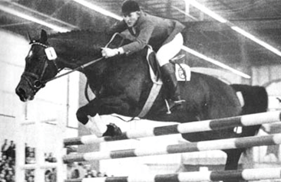
Yet Landgraf was not initially widely accepted as a stallion in Germany because sons of Thoroughbreds were still regarded with suspicion. It was after the 1975 Equitana in Germany, where Landgraf easily cleared a 6’6″ several times a day that international riders started to buy his offspring.
Landgraf was not really accepted – until he proved he could jump!
Born in 1966, Landgraf I belongs to the first vintage of his sire, Ladykiller xx.
His dam, Warthburg, came from the stem No. 275 and carries the performance genes of Ethelbert, Achill and Cicero, who are responsible for laying the foundations of the Holsteiner Sporthorse.

Landgraf was licensed in 1968 along with twelve other sons of Ladykiller xx. Landgraf finished in 5th place with the comments: ‘a lot of presence, good gaits with excellent propulsion, good conformation and average hindquarters.’
Landgraf was chosen to represent the Holsteiner breed at the 1972 DLG (a nationwide show run by the German Department of Agriculture) and finished last. Following protests from the Holstein officials, this was converted into second place, and then in an elegant piece of gobbledegook to ‘first place C’.
As a sire, the list of his showjumping offspring is impressive. For example: Freestyle (formerly Lalique) won Aachen Grand Prix, Libero won the Dutch National title five times and the 1994 Volvo World Cup. The licensed stallion, Lacros, is another, along with top performers: Lucky Luke, Lanciano, Landlord, Lausbub and Taggi.
Nearly sixty colts by Landgraf I have been licensed for the Holsteiner studbook, like the licensing champion of 1991, Linaro, and the dressage talent, Loutano. Perhaps his most valuable son was the versatile Landadel, who produced three champion stallions for the Oldenburger breed alone, and World Cup finalists in both dressage and jumping.
340 broodmares by Landgraf I are registered in the Holsteiner stud book, 260 of these are in the Head Stud Book, 70 have been awarded the State Premium, and a considerable number have been champion mares at shows. In his Stallion Book of the Holsteiner Warmblood Breed, Dr Dietrich Rossow delivers his verdict on Landgraf:
“Imposing appearance with enormous crest and neck carriage. Smooth total topline and much presence. Beautiful face with marvelous eye. Long, rather broad neck, long sloping shoulder. Withers could be more clearly defined. Well-shaped, muscular croup. Strong bone. Good in front. Slightly sickle hocked in youth (became very straight with age). Tied in below the hock and faults in the hind fetlocks. Good mover. Marvelous temperament. Phenomenal jumper; tight in front, lots of bascule, careful and talented. Great performance capabilities.”
“Offspring are of various sizes and usually late developers. In youth, the tall ones appear leggy and narrow. Nearly always passes on his face, type and also his hindleg faults. Almost all offspring are endowed with their sire’s jumping ability. In the beginning they jump rather awkwardly with less than ideal form which improves with increased maturity. Seldom passes on his overly heavy neck. Huge number of international class jumpers. Up to now (the book was published in 1988) Landgraf is far and away the most important jumper sire in the world!” In all, Landgraf progeny have won over €4.3 million.
In the 2007-2008 edition of Monneron, on the basis of his list of the top 75 stallions in the world, Bernard le Courtois identifies four dominant male lines: Almé, Cor de la Bryère, Capitol and Landgraf. Landgraf is the sire of five stallions out of the top 75, with two in the top ten. The most successful of his sons is Burggraaf, who has 26 winners to occupy 6th place. The World Cup winner, Libero is in 9th place with 22 CSI winners. That year, Libero was the only stallion with two representatives – Libertina and No Mercy – in the World’s top ten performers.
Landgraf is also represented on le Courtois’ list by Landadel, who despite dying at the age of 13, occupies 30th with 10 winners. Landadel’s son, Landfriese I, ranks 52nd with 6 successful competitors.

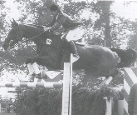
Warthburg Holstein Stamm 275
Warthburg, came from the stam No. 275 and carries the performance genes of Ethelbert, Achill and Cicero, who are responsible for laying the foundations of the Holsteiner Sporthorse. Warthburg was born in 1962 and was bought as a weanling by Baron Friedrich Christian von Kielmansegg. After a competition career as a jumper, she produced:
- Jenni, by the Thoroughbred stallion, Little Lion xx. Jenni is the dam of Orchidee, who was a member of the gold medal winning German jumping team at the Seoul Olympic Games with Dirk Hafemeister. Orchidee in turn was the dam of Avion (Athlet Z) ridden in international competition by Ludger Beerbaum.
Warthburg then produced six foals by Ladykiller xx.
- Landgraf was born in 1966, the following year saw his full brother.
- Landgraf II, who was sold to the south of Germany where he was gelded. Under the name – Leon III – he went on to compete at Grand Prix level with Manfred Schlusselburg.
- In the following two years, the fillies Eva and Frederica were produced – Frederica when bred to Farnese produced the licensed stallion, Fredericus.
- In 1970 Warthburg produced another filly, Landgrafin who was ridden in the 70′s and 80′s by Hugo Simon, winning many speed and puissance classes. Bred to Cor de la Bryère, Landgrafin then produced the stallion Cash, who also competed internationally with Hugo Simon before his death at the age of 10 while competing at Aachen. She also produced the mare Deichgräfin 13 by Constant which competed at ISJ Level 1.60m with Carsten-Otto Nagel (DEU) 1st CSI-W 2000 - World Cup 2000 Helsinki (FIN) (1.60m); 1st CSI-W 1999 - World Cup 1999 Helsinki (FIN) (1.60m); 3rd CSI-W 2000 - World Cup 2000 Göteborg (SWE) (1.60m).

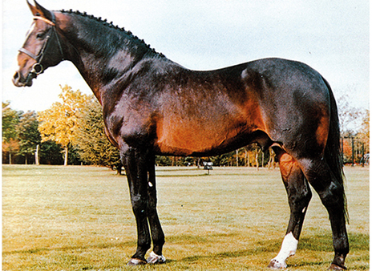
Ramiro z by Raimond from Valine H by Cottage Son xx
Ramiro is by Raimond which in turn is by the influential Anglo stallion, Ramzes which stood twice in Holstein and in his second stint, produced four licensed stallions: Roman, Rigoletto, Raimond and Rhenus. Rigoletto was sold to The Netherlands, while Rhenus ended his days in the circus tent. Roman became a good competition horse, and an excellent sire of broodmares. Raimond was a more attractive type than Roman and sired over 120 daughters and eight stallions, but of these, only Ramiro was a success.
Ramiro descends from one of the oldest and most successful Holstein stamms 776 which was ranked No. 1 female line out of the top 25 female family rankings in the world for the production of showjumpers, (Sporthorse Breeding Magazine Sept. 2008).
Conceived in Holstein, born in Westfalia, licensed at Neumünster, and himself an international performer under Fritz Ligges, Ramiro influenced nearly all European Performance Studbooks.
Ramiro was the most popular representative of the Ramzes line and at one stage was the most frequented sire in Germany. He stood at stud in Westfalia, Holstein, Zangersheide and Holland.
When Ramiro was presented for selection, he was described as the ideal type of the modern Holsteiner – strongly imprinted by his dam, tall and elegant, showing the top line of his grandfather, Cottage Son xx, with powerful frame, a glorious face and large, clear eyes. His excellently formed neck, beautifully set, could still be seen – even when he was an old horse – and is stamped on his progeny. Ramiro displayed a very good walk, a normal trot, and a great canter.
Ramiro was by the Ramzes son, Raimond who was born in 1960 out of Infra by Fanaticker. According to The Holsteiner Horse, “his progeny were very uniform, true-to-type and of good character, were trustworthy and easy to ride. Raimond sired well over 120 daughters who were held in high esteem, especially when they were out of Thoroughbred mares.” He was the sire of eight approved sons but only Ramiro, born in 1965 out of the Cottage Son daughter, Valine, was successful. He was the only foal of Valine, who went to Italy where she was a successful jumping competitor.
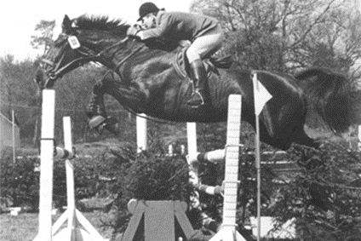
Valine H, the mother of Ramiro
Again, let The Holsteiner Horse, tell the story:
“Even as a yearling, Ramiro radiated high quality and sovereignty. As a two and a half year old, he was runner up at the Holsteiner licensing in Elmshorn. He was very big, already standing 1.75 metre high as a three year old, with a clever head on a long, beautifully arched neck. Gentle to handle, just like his grandsire, Ramzes, he was very talented at jumping, which he not only proved by finishing the stallion performance test in Westercelle as the best of his year, but also later at international level with Fritz Legges. However, at the time he was already a self confident stud stallion and occasionally tested his rider with a trial of strength.”
Ramiro first stood at the Vornholz stud where his grandsire, Ramzes stood. In that period he sired the World Cup finalist, Danau (Fatinitza) and the licensed stallion, Romanow. The Holsteiner Association leased Ramiro for just one year, 1969, for half of a stud season.
Ramiro was among the early stallions to compete. During his own sporting career, Ramiro had numerous wins at all levels of showjumping – Nations Cups, Puissance (jumping over 2.2 metres) and in international Grand Prix competition.
In 1974, after his competition career ended, Ramiro was first sold to Fritz Legges’ sponsor, Rudolf Hirschmann but he was then acquired by Zangersheide Stud where he became part of Leon Melchior’s two pronged breeding program – Almé and Ramiro.
Ramiro’s influence on the Dutch Warmblood breeding was, and still is, of utmost importance. The Dutch bestowed the title – ‘Horse of the Year’ – on Ramiro in 1992.
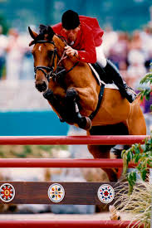
Based at the Zangersheide Stud, Ramiro was presented with a selection of superbly bred jumping mares. His most famous ‘nick’ was with the foundation mare, Heureka. Argentina Z, the Heureka daughter by Almé, produced with Ramiro the stallion sons: Rebel I Z, Rebel II Z, Rebel III Z and Rock Z, none of whom were wildly successful, but their full-sister Ratina Z was a superstar. Ridden by Piet Raymakers and Ludger Beerbaum, she won World Cup Finals, the European Championships, the Grand Prix of Aachen, individual Olympic Silver, double Olympic Team Gold, Team Gold at the WEG, and twice team gold at the European championships and dam of the stallion Comme il Faut. Like his grandsire, Ramzes, Ramiro was more a broodmare producer than a stallion maker.
Perhaps his most successful son was Ronald out of Adrette by Heilbutt from Dorette by Monarch (Dorette is also the dam of Ella, the dam of the stallion ’Constant’ who is the sire of the great Olympic competitor and stallion ‘Chin Chin’ and the dam of Ulla V by Cor de la Bryere the dam of the sire Quantum by Quidam de Revel. Dorette also bred the good sires ‘Roman’(sire of top class dams including Monoline dam of three licenced sons Cantus, Calvin Z and Lansing) and ‘Farn’, (sire of the great grand prix jumper stallion and sire of sires ‘Nimmerdor’).
In the survey of the world’s top 75 jumping sires that appears in the French publication, Monneron 2007-2008, Ramiro (who thanks to frozen semen was still producing foals 12 years after his demise), is ranked 23rd with 11 CSI winners, while his son, Robin I Z is 43rd with 7 representatives.
One of the last of the Ramiro’s – the stallion Van Schindels Rascin is competing Grand Prix with Piet Raymakers
While he may not have established a sire line, Ramiro blood prevails in the mare lines, perhaps the most outstanding example is Gofine by Ramiro, who is the dam of Contender.
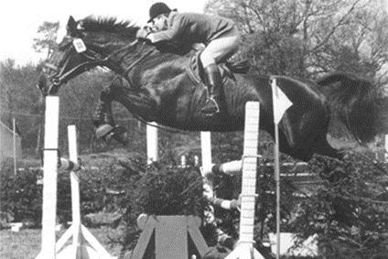
RAMIRO z Line Holstein Stamm 776
For generations already the Holsteiner stamm 776 is known as a mother line that produces champions. This Holstein stamm was ranked No. 1 female line out of the top 25 female family rankings in the world for the production of showjumpers, (Sporthorse Breeding Magazine Sept. 2008). Of this famous Holsteiner Stamm line are more than 65 approved stallions, such as Crunch, Livello, Landos, Calvados I and II, Cortino I and II, Lord Incipit, Captain Incipit, Lauritz J, Rossinim Acorado1-11, Caracas, Lordanos, Ramirado Contiki, Toledo, Lucky Boy, My Lord, Cassino Z, High Valley Z, Bøgegårdens Quattro and world-class sire Ramiro who is present in may top showjumping horses and sires. Stamm 776 also produced international jumping horse Aluta, Leandra, My Lord, Cornwall W and S.I.E.C. Livello.
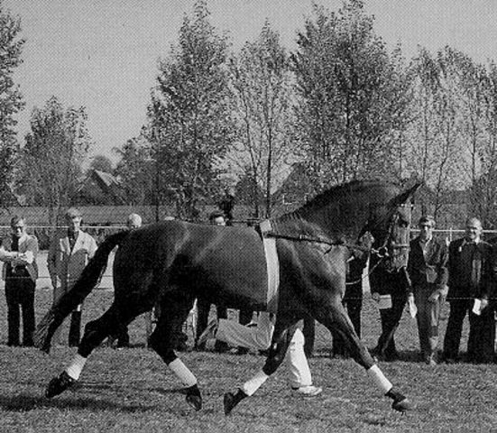
Calypso 1 by Cor de la Bryere from Tabelle by Heißsporn Calypso I was an incredibly important sire to the Holsteiner breed and consistently passed on his best qualities to all of his offspring. Calypso I has been established as one of the great sires of dressage horses. Next to that we know him also as father of a series of international jumping horses, of which Calando (Björn Nagel) and Cabinett I (Dirk Schröder) are best known of. Calypso I had a smooth, harmonious top-line with a well carried neck and lots of expression. Beautiful shoulder and wither. Strong bone, correct legs and feet with high set on hocks. He had well defined joints and was a marvellous mover. He consistently passed on his best qualities to all of his offspring. His offspring have elegant Calypso type and are endowed with fabulous basic gaits with fantastic trot and all show extraordinary jumping ability. His offspring are correct and elastic with scope as dressage horses and jumpers. Calypso I produced 10 approved sons and 147 approved daughters. Calypso I was licensed in 1975 at Neumunster, completed the 1976 Adelheidsdorf 100-day stallion performance test.
• Chacomo- bay gelding out of Paranka (Marmor). 1999 German Federal Reserve Champion Dressage horse, 1999 Team Gold at the European Dressage Championships, and team gold at the 2000 Sydney Olympics. Ridden by Alexandra Simons De Ridder. Half-brother to Cor Noir.
• Calipso- chestnut stallion out of Cori (Cromwell). Licensed in 1988 at Oldenburg. Successful up to European Level S show jumping.
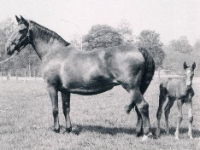
Tabelle Holstein Stamm 65
Tabelle 1959 by Heißsporn, produced six approved stallions, starting with Congress by Consul, then when bred to Cor de la Bryère, the five Calypso brothers – all of whom were useful horses and valuable sires and the mares Heidi by Marlon xx and Tibris by Cor de la Breyere. Tabelle is a full-sister to Salmei, who was the dam of the great Granat, a Olympic, World and European champion dressage horse with Christine Stückelberger.
- Congress by Consul approved stallion.
- Heidi by Marlon xx
  - Violis by Othello dam of Lehnbach S stallion by Landgraf I.
- Calypso I by Cor de la Bryère) Approved Stallion
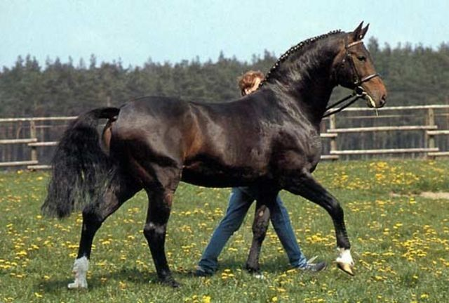
- Calypso II by Cor de la Bryère) Approved Stallion. Calypso II has been one of the most important sires in both Holstein and Hannover where he bred international competitors, with great jumping form and ridability. It was Calypso II who introduced the Cor de la Bryère blood to Hannover, ushering a new era of Hannoverian jumping breeding. Calypso II produced a number of international performers including Calyno, Cheyenne, Crazy Cocktail, Montemorelos la Silla, Caras J, Dobel’s Cara Mia, Asien, Cartier S, Capella 3, Champ of Class and Zarina de San Patrignano. All Calypso II progeny show not only great jumping form, but also a wonderful rideability. He produced winners of one and a half million deutschmarks, with 557 competitors. On the basis of the Hanoverian mare tests, Calypso II achieves a dressage ranking of 131, and a jumping ranking of 167. His breeding index on the basis of his competition horses is 132 for dressage and 150 for jumping.
Calypso II produced a number of licensed sons: Cadiz, Calimero, Carbid, Cardano, Caribik, Caribo GL, Caribu, Carismo, Champ of Class, Chasseur I and II, Chevaliero, Classiker, Colambo, Colani, Compliment, Confident, Contender, Cordino, Coriolan, Colando, Corso, Crazy Classic, Crazy Cocktail, Cristobel, Cyrell.
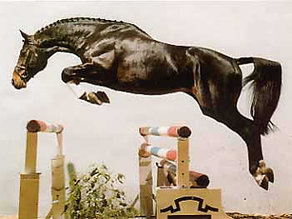
- Contender from Gofine (Ramiro). USEF 2008 #25 Dressage sire. Contender is the most influential son of Calypso II and one of the greatest of the stallions to descend from Cor de la Bryère. He has produced 127 approved sons, and 59 state premium mares including Riconda who won the Elite Mare Show at Rastede in 1993. As of 2006, in Holstein, Oldenburg, Hannover and Rhineland, Contender had produced 782 registered mares, 498 successful offspring in the sport. One of the most popular sires in Germany. The FN breeding values list him as one of the most versatile sires ever.
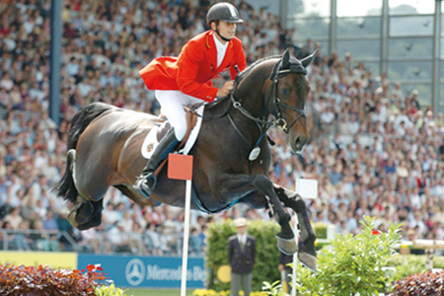
  - Montender (1994-) dark bay or brown stallion out of J'Esprit (Burggraaf). Jumped under Marco Kutscher to individual bronze and team gold in the 2004 Olympics.
  - Contango (1988-) brown stallion out of Adisa III (Kronprinz xx). USEF #2 Dressage Sire and WBFSH #14 Dressage Sire in 2008. Influential sport horse sire in North America.
  - Contendro (1997-) brown stallion out of Bravo (Reichsgraf). USEF #50 Dressage Sire and #35 Hunter Breeding Sire in 2008.

- Cor de Calypso by Cor de la Bryère IEV 4* with Herbert Blöcker (DEU)
- Calypso III by Cor de la Bryère Approved Stallion
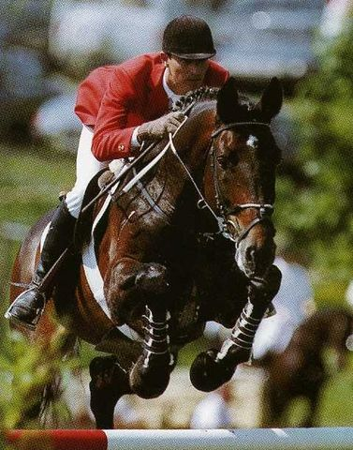
- Calypso IV by Cor de la Bryère Approved Stallion. Licensed in 1980 at Neumunster, completed the 1981 Adelheidsdorf 100-day stallion performance test. From 1983-1987 he was exclusively a show jumper, and was successful up to S-level.
- Calypso V by Cor de la Bryère) Approved Stallion
- 1981 Tibris, mare by Cor de la Bryère
  - Artemis mare by Rebel Z I, dam of Anloka, ISJ Level 1.50m
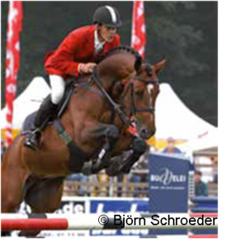
  - 1990 Elypse I mare by Lavall I dam of
    - Askari by Acord II, Approved Stallion: Hann, Holst, Old, SA, Brand, OS, BA- ISJ Level 1.50m
    - Asgard 17 by Acorado I, ISJ Level 1.60m
    - CARITO, stallion by Carthago Z: ISJ Level 1.60m
    - Faust de Hus Z by For Hero de Hus, ISJ Level 1.40m.
  - 1991 Fürstin I, mare by Landgraf I, dam of Fürst Calypso by Franklin, Approved for: ZfdP
    - dam of Cassalando by Casall ASK, Approved stallion: Sachs, SA, BA
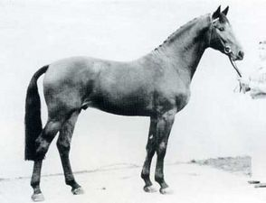
Ladalco by Ladalco from Zala by Aldato
Ladalco is a son of the great thoroughbred Ladykiller xx from the Aldato mare Zala. Hence Ladalco shares the same sire (Ladykiller xx) and the same damsire (Aldato) as the great Landgraf I. Ladalco is the full brother of Derby winner Boy ridden by Eddi Macken of Ireland. Ladalco produced international showjumpers such as Lasando, Febo's Idalco, Lugano H and Joker. Ladalco is also the sire of the Holsteiner stallions Laurin, Lenard. In total Ladalco produced four approved sons and 53 approved daughters. He can be found as dam sire of many Licenced stallions and top performance horses, for example, Ladalco is the great dam sire of Winningmood.
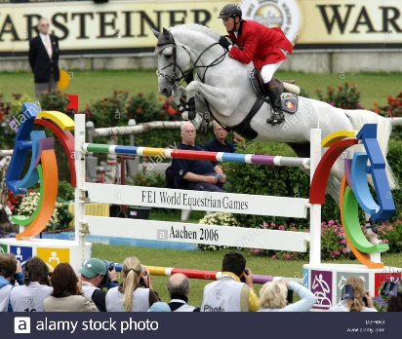
mARIETTA hsp Holstein Stamm 328D1
The dam line 318D1 is one of the most successful lines in Holsteiner breeding. It is the line of World Champion Cavalor Cumano ridden by Jos Lansink and the Derby winner Boy (Eddi Macken/IRL), who is full brother of the licensed stallion Ladalco (by Ladykiller xx). Furthermore, the following licensed stallions also descend from this damline: Labrador, Little Boy, Casiro 1, Casiro 11, Casino, Centesimo I and II, Counter Star, Fokus I and II, Grand Liaison, Landaris, Libretto, Resolut and Wildfang.

Something to think about
Below is from this website http://www.sport-horse-breeder.com/breeding-principles.html
These are the breeding principals a lot of successful breeders follow, they talk a lot about superior mares, strength in the engine room (4-7 generation), sex balancing and bringing the power forward in the pedigree- it is very interesting. So in the mares I have I can strengthen their pedigrees by targeting ancestors so that when crossed back to Quantro, were enforcing superior mare lines. Cera Quantro has a lot of superior marelines in his pedigree he is a great start when strengthening a pedigree. The strength of Cera Quantro’s pedigree is clearly the versatile background, proven to the Olympic level in all three disciplines.
Breeding Principles- Use the Statistically Proven Tesio Methods to Create a Great Sport Horse
This is a short outline of the statistically proven breeding principles known also as the Tesio Methods. The following principles of successful breeding were identified, tested and developed by the Thoroughbred Industry. We have adopted and adjusted these breeding steps to fit our sport horse goals. These key points are backed up by statistical evidence, so you can be confident that there is a documented history showing that these steps work. What we have learned from their success is that in order to breed a better sport horse we should attempt the following:
1. Learn the pedigree (it is your horse's genetic map)- so that you can understand the genetic strengths your horse possesses.
2. Have a breeding goal and determine which bloodlines will help you get there.
3. Linebreed- by finding a mate who will multiply the lines of superior ancestors in your horse.
4. Sex balance those lines- find a mate with the daughters and sisters of your good male lines, or the brothers and sons of your female lines.
5. Reinforce the bloodlines by engaging the background strength of the pedigree.
6. Bring in siblings- full if possible, or 7/8, 3/4, 5/8 or 1/2. Statistics show that full or 3/4 siblings send the genetics into high gear.
7. Repeat the breeding- to insure the best sport horse outcome in one of your foals.
The researchers found that when the quanity and the complexity of the bloodlines reach what they called 'critical mass' then the champions appear on a regular basis.
This site will discuss the above principles in depth.
http://www.sport-horse-breeder.com/breeding-principles.html
Line Breed to superior Mare
How Important is the Mare in Sport Horse Breeding?
It might interest you to know that the mare was the primary focus of Tesio. He structured his breeding program on his broodmares- he seldom stood a stallion at his farm. For his broodmare herd he sought out mares that carried specific bloodlines he was interested in- for instance he chose Catnip because she was a Spearmint daughter and got her at a bargain price because Spearmint was not a bloodline in demand at the time. Spearmint, although a great racer also had poor front legs, so he was avoided as a sire- at least for a while- until it became obvious to all he was a great sire of winners. Tesio of course was looking at his genotype not his phenotype so he snatched up Catnip. He was always searching out sources of impulsion and he thereby made it his goal to build up multiple lines of the mare Brown Bess in the background of his pedigrees because she was a source of soundness and tremendous impulsion coming from strong hocks (found close up in Spearmint). For each of his mares he painstakingly sought out the best genetic match for her from horses that had been 'performance' tested at the classic races. In addition, he was so committed to a particular match that if he could not obtain a breeding to the stallion of his choice then he would seek a breeding with a full brother or son- rating the genetics above the performance quality of the near relative. Tesio can teach us alot.
Understanding your breeding stock's genetic strengths and weaknesses can be the greatest tool you have in your quest for sport horse excellence. Recently a recognition of the power of the mare has become a focus in equine breeding. Although the genetic contribution of both parents is very important, a realization has surfaced that the maternal strength might instead be responsible for more of the foal's attributes.
The discovery of the large heart gene, a sex linked trait, was one exciting example of this. Another instance is the advances that have been made into Mitochondrial DNA research, both in humans and equines.
"Around the globe you will see the most successful farm operators active at acquiring quality mares and fillies, they know maternal strength is the pathway to success."(McLean)
It took them quite a while to get to this point of view. In the early days of the stud book mares seldom got a name of their own, more often they carried names like "daughter of Glencoe" or "Sedbury Mare" identified only in relation to their sire. This had made the study of early Thoroughbred pedigrees difficult. It is worse trying to study Warmblood and Sport Horse lineages- often the mare is just "unknown".
Knowledge in any field comes from the hard work of many people. The advances in equine genetics and breeding are no different. Following are just a few of the "giant's shoulders" we are standing on today.
Frederico Tesio, the father of balanced linebreeding, was an intuitive genius, instinctively he chose broodmares with reserves of nervous energy- this was long before Mitochondrial DNA was ever imagined.
Ken McLean in his "Genetic Heritage" announced the importance of the dam's x chromosome and he anticipated the future findings in Mitochondrial DNA.
Bruce Lowe attempted to trace and classify those female families that were potent for racing excellence in a number system that is still in use today.
Ellen Parker has developed a 'reine-de-course' list to identify the top producing broodmare lines in the Thoroughbred.
Clive Harper gave us the statistics that have clearly shown that sex balancing pays in his "Thoroughbred Breeders' Handbook" and then explored the power of the mare in depth in his "The Thoroughbred Broodmare Book".
Marianna Haun thrilled us with her "The X Factor" which traced the large heart gene coming down the x chromosome.
The above is a partial list, but enough for you to see that all of these ground breakers were ON TO SOMETHING.
What does this mean for the breeders of Sport Horses? Briefly, because equine genetics work the same no matter the breed of horse, we should employ all the knowledge the Thoroughbred Industry is providing. In particular, we should make breeding decisions with an awareness of the strength of superior mare lines- and we should take steps to bring forward this power to our sport foals.
Just as in human research, the equine researchers are able to trace the Mitochondrial DNA back and determine true ancestry. This is a huge help now, and will be even more in the future, when we will be able to fill in those gaps in our sport horse pedigrees. For example, it was discovered by this method, that the general stud book (Thoroughbred) had far fewer foundation mares than they originally thought. And it also turned out that some of the foundation mares were recorded several times, but with different names, plus many of the mares were also found to share a common mother. Never before have we had a tool like this-one that can verify bloodlines.
It is well established that proper energy conversion in the cells is essential for good muscle performance. As breeders of horses that we hope will excel in sport we should pay close attention to any new developments in Mitochondrial research.
Evaluation done of the pedigrees in the Thoroughbred Industry revealed that particular pedigree patterns produce either better fillies or colts, and that there also was a difference between good breeding stock (both stallions and mares)when compared to the pedigree design of performance only winners. See Potency Primer page for more on this.
We are living in exciting times for sport horse breeders as every year there seems as if some significant discovery is made concerning sport talent and genetic transmission. For instance, in 2010 the Dr Mims Bower and her research team published their findings that the original foundation mares of the Thoroughbred were not 'arabian' as long believed, but were what she calls 'native' British and Irish mares- these individuals we know as Running Horse and Irish Hobby mares from the historical records (MacKay-Smith 'Speed and the Thoroughbred'). Then in January of 2012 Dr. Emmiline Hill and her associates further expounded on this, by tracing the 'speed' gene back to "..a British mare about 300 years ago, when local British horse types were the preeminent racing horses, prior to the foundation of the Thoroughbred racehorse." Read the article below.
Dr. Emmiline Hill- speed gene article
This is the same root stock that the American Colonists imported for race and saddle stock. The Irish team determined that the American Quarter Horse carries the speed gene also.
There is an irony in this, in that science is finally catching up with the conclusion that speed in the racehorse originates with the Hobby-bred mares of the old racehorse studs of Ireland and England. The scholars I mention are John Wallace who in the 1800s, after 50 years of pedigree research and the establishment of two registries for trotting racehorses, determined that speed at both the gallop and the trot originated with the pacing bloodlines. What has this to do with the 'speed' gene? Those early racehorse mares were gaited, the Hobby was a gaited breed, which possessed large amounts of stamina as well. The racing trot, with its low straight forward motion developed from the pacers- the eleveated showy trot comes from a different source. (See Standardbred article for more on this).
A more modern scholar who came to the same conclusions is Alexander MacKay-Smith, he believed that speed originated with the Hobby. They published their work in : Wallace "The Horse of America in his Derivation, History and Development" 1897 and MacKay-Smith "The Colonial Quarter Race Horse" 1983 and "Speed and the Thoroughbred" 2000.
America is blessed with tremendous domestic resources for the sport horse breeder as we have 3 racehorse breeds (TB, QH, ST) plus a multitude of other light horse breeds that descend from this same root stock: Morgan, Saddlebred, Tennessee Walker and Missouri Fox Trotter.
We can capitalize on this science by making an effort to understand the proven mare lines our stock may carry. This will be easier for some breeds then others. For instance, the Holstein association has always put an emphasis on 'stamm' lines (maternal families), and therefore the genetically potent mares will be relatively easy to identify. The Trakehner Horse is another breed that has valued its exceptional female lines, to the point that the stallions are named by the first initial of the dam's name, rather than the other way around. Thoroughbred breeders have classified especially potent mares as 'blue hens' and Ellen Parker developed her 'reines-de-course' list and made an indepth study of the female families. With the computer databases available we can also trace our other American breeds back, and therefore find the early transmitters of this sport talent, then locate the modern carriers and build them up in our sport stock. With other breeds it may be harder, but not impossible.
To identify good target mares for your linebreeding, look to broodmares who have more than one excellent offspring. When you have identified a mare in the pedigree you believe is a good subject, then look for her siblings (full if possible) or her sons and daughters in your mating choices. Once you have found a good mare line in your gene pool lineage, make that mare one of your linebreeding targets. This is what the successful Thoroughbred breeders are doing - they are linebreeding to dominant mares- with spectacular results.
Great maternal influences are much harder to find then those coming from stallions. Mares only produce an average of 5-10 foals in their lifetime, compared to a stallion average of 250-500 offspring. So, any mare that has more than a few good progeny is a mare to treasure.
Clive Harper, Thoroughbred pedigree expert, said: "Start with what strength the mare has- always looking very, very closely at the dam line- and build in the complimentary and supplementary names."
One of the most productive practices you can assume in your breeding program is to build up powerful broodmare families. When planning a mating for a stallion use your best mare.
Following are examples of using these principals with Cera Quantro.

Offspring of Arezzo x Premier Diamond (Azar Diamond) crossed to Cera Quantro
 | Cera Quantro  AU-14-CH | Quantum  DE-94-DB | Quidam de Revel  FR-82-B | Jalisco B | Almé Z
 |  |  |  |  | Tanagra
 |  |  |  | Dirka | Nankin
 |  |  |  |  | Ondine de Baugy
 |  |  | Ulla V  DE-82 | Cor de la Bryere | Rantzau
 |  |  |  |  | Quenotte
 |  |  |  | Ella | Colt
 |  |  |  |  | Dorette
 |  | Valenzia BP  DE-0x | Carinjo  DE-01-B | Cascavelle | Cantus
 |  |  |  |  | Phaedra
 |  |  |  | Exquisite | Landgraf I
 |  |  |  |  | Grossfürstin
 |  |  | Cayenne III  DE-88-BR | Calypso I | Cor de la Bryere
 |  |  |  |  | Tabelle
 |  |  |  | Valenzia | Ladalco
 |  |  |  |  | Lublin
Future Litter
 | Virtual-Dam  - | Arezzo  NL-05-CH | Chin Chin  DE-MAR-78-B | Constant | Cor de la Bryere
 |  |  |  |  | Ella
 |  |  |  | Larese | Farnese
 |  |  |  |  | Cesta
 |  |  | Sarjolijn  NL-99-BR | Heartbreaker | Nimmerdor
 |  |  |  |  | Bacarole
 |  |  |  | Farjolijn | Renville
 |  |  |  |  | Parjolijn
 |  | Premier Diamond  AU-06-B | Premier des Hayettes  BE-92-BR | Concorde | Voltaire
 |  |  |  |  | Flyer
 |  |  |  | Calbonny | Nimmerdor
 |  |  |  |  | Albonnie Z
 |  |  | Close Encounters Mare  -0x | Close Encounters | Contact
 |  |  |  |  | Caress Me II
 |  |  |  | unknown | unknown
 |  |  |  |  | unknown

Alme thru the son Jalisco B m-5, and thru the daughter Albonniez f-6 ( Alme sex balanced thru 2 important producing off spring)
Nimmerdor (by Farn) thru the son Heartbreaker f-4 and thru the daughter Calbonny f-4 ( Nimmerdor sex balanced thru 2 important producing offspring as well as adding power to the Dorette Line, as Farn is a son of Dorette)
Dorette thru the son Farn- f-7,f-7, thru the daughter ella m-4 f-5, thru the son Roman m-8
Ella thru the son Constant f-5 and thru the daughter Ulla V m-4 (full siblings)
Cor de la Bryere thru the son Contact f-6, thru the son Constant f-5, thru the daughter Ulla V m-4,(Constant and Ulla V are full siblings), thru the son Calypso 1 m-5, thru the son Caletto 1 m-7, thru the son Calando 1 m-7

Offspring of Ego Creighton x Holmwood Crystal crossed to Cera Quantro

 | Cera Quantro  AU-14-CH | Quantum  DE-94-DB | Quidam de Revel  FR-82-B | Jalisco B | Almé Z
 |  |  |  |  | Tanagra
 |  |  |  | Dirka | Nankin
 |  |  |  |  | Ondine de Baugy
 |  |  | Ulla V  DE-82 | Cor de la Bryere | Rantzau
 |  |  |  |  | Quenotte
 |  |  |  | Ella | Colt
 |  |  |  |  | Dorette
 |  | Valenzia BP  DE-0x | Carinjo  DE-01-B | Cascavelle | Cantus
 |  |  |  |  | Phaedra
 |  |  |  | Exquisite | Landgraf I
 |  |  |  |  | Grossfürstin
 |  |  | Cayenne III  DE-88-BR | Calypso I | Cor de la Bryere
 |  |  |  |  | Tabelle
 |  |  |  | Valenzia | Ladalco
 |  |  |  |  | Lublin
Future Litter
 | Virtual-Dam  - | Ego Creighton  AU-07-BR | Camelot Ego Z  AU-DEC-98-BR | Carthago Z | Capitol I
 |  |  |  |  | Perra
 |  |  |  | Ego Guinivere | Grannus II
 |  |  |  |  | Stirling Monorose
 |  |  | Doctor's Point Princess  AU-NOV-86-GR | Pfrinzen | Flaneur
 |  |  |  |  | Molly Malonie
 |  |  |  | Doctor's Point Maria | Supreme
 |  |  |  |  | Craigie Lea Dublin
 |  | Holmwood Crystal  AU-DEC-05-CH | Champion FP  DE-00-CH | Champion du Lys | Laeken
 |  |  |  |  | Karene du Lys
 |  |  |  | For Joy | For Pleasure
 |  |  |  |  | Dodo
 |  |  | Amy M  AU-9x | Limbo Rock | Valeur
 |  |  |  |  | Koyuna Supremacy
 |  |  |  | Treska | Digital
 |  |  |  |  | Lobivia

Fangelika line breed through 3 quarter sisters Perra f-5 thru a son and Phaedra m-5 thru a son
Grannus. F-6 thru male Grannus 11, f-7 thru Gigantin dam of For Pleasure
Souvenir thru the son Supreme and thru the daughter Supremacy.f-6 (full siblings)
Koyuna Felicity thru the son Supreme and daughter supremacy.f-6 (full siblings)
Cor de la Bryere- f-7 thru the son Calando 1, m-5 thru the son Calypso 1, m-4 thru the daughter Ulla, m-7 thru the son Caletto 1, m-7 thru the son Calando 1

Offspring of Lenny x Parkview Julia crossed to Cera Quantro
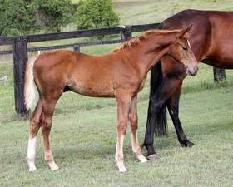 | Cera Quantro  AU-14-CH | Quantum  DE-94-DB | Quidam De Revel  FR-82-B | Jalisco B | Almé Z
 |  |  |  |  | Tanagra
 |  |  |  | Dirka | Nankin
 |  |  |  |  | Ondine De Baugy
 |  |  | Ulla V  DE-82 | Cor de la Bryere | Rantzau
 |  |  |  |  | Quenotte
 |  |  |  | Ella | Colt
 |  |  |  |  | Dorette
 |  | Valenzia BP  DE-0x | Carinjo  DE-01-B | Cascavelle | Cantus
 |  |  |  |  | Phaedra
 |  |  |  | Exquisite | Landgraf I
 |  |  |  |  | Grossfürstin
 |  |  | Cayenne III  DE-88-BR | Calypso I | Cor de la Bryere
 |  |  |  |  | Tabelle
 |  |  |  | Valenzia | Ladalco
 |  |  |  |  | Lublin
Future Off Spring
 | Lenny | Lux Z  BE-88-B | Lord Calando  DE-85-B | Lord | Ladykiller
 |  |  |  |  | Viola
 |  |  |  | Perra | Calando I
 |  |  |  |  | Kerrin
 |  |  | Apocalypte  DE-85-B | Ahorn Z | Almé Z
 |  |  |  |  | Heureka Z
 |  |  |  | Sanntona | Caletto I
 |  |  |  |  | Hedie
 |  | Holland Rose  FR-JUN-95-B | Quidam De Revel  FR-82-B | Jalisco B | Almé Z
 |  |  |  |  | Tanagra
 |  |  |  | Dirka | Nankin
 |  |  |  |  | Ondine De Baugy
 |  |  | Jolie Rose  NL-APR-91-BR | Un Repaire | Fast
 |  |  |  |  | Gibsy
 |  |  |  | Gold Rose | Ibrahim
 |  |  |  |  | Jolie Rose Z
 | Parkview Julia  AU-00-CH | Close Encounters  AU-85-BK | Contact  DE-74-B | Cor de la Bryere | Rantzau
 |  |  |  |  | Quenotte
 |  |  |  | Sektion | Grant II
 |  |  |  |  | Imsel
 |  |  | Caress Me II  AU-68-BR | Carioca | Felt Yet
 |  |  |  |  | Sing Again
 |  |  |  | Lovenest | Kilokan
 |  |  |  |  | Eagle's Nest
 |  | Parkview Rapunzel  AU-8x | Clever  AU-66-CH | Better Boy | My Babu
 |  |  |  |  | Better So
 |  |  |  | Golden Chariot | Golden Sovereign
 |  |  |  |  | Speed
 |  |  | unknown | unknown | unknown
 |  |  |  |  | unknown
 |  |  |  | unknown | unknown
 |  |  |  |  | unknown
When off spring crosses back to Quantro
The Mare Fangelika thru ¾ sisters Perra ( dam of Carthago & Lord Calando) and Phaedra ( dam of Cascavelle) No. 6 mare line in the world in 2008 but I think it is now no. 2
Quidam De Revel (sex balanced) thru a producing daughter Holland Rose and a producing son Quantum
Alme thru the sons Ahorn Z and Jalisco B twice
Ibrahim thru important producing daughter Gold Rose and son Alme 3 times
Cor De La Bryere thru the daughter Ulla V, Sons Contact, Caletto 1 (twice thru a son and daughter), Calando 1 (twice thru daughters), and Calypso 1.
Next Generation: Maybe could target the mare Gold rose- Grand dam of Holland Rose by Quidam De Revel and- Dam of Calvados by Uriel ( Uriel and Quidam de Revel have the same mare line of Nadine, so this would concentrate the Nadine mare line too- Ranked 23 in the world ) Actually Uriel and Dirka are ¾ siblings in blood. This could be done by using the stallion Etoulon VDL which will be available in Australia shortly, or Picobello by Calvados. When using Picobello then the opportunity is present to concentrate the Diastolechen mareline the Joost when crossed the Cera Quanto.
 | Calvados  SF-FR/NL-APR-84-CH | Uriel  SF-FR-MAR-64-CH | Nankin  FDS-FR-APR-57-B | Fra Diavolo | Black Devil
 |  |  |  |  | Frayeur
 |  |  |  | Constellation | Plein d'Espoirs
 |  |  |  |  | Henriette
 |  |  | Jesabelle de Baugy  FDS-FR-53-CH | Ascot | Plein d'Espoirs
 |  |  |  |  | Rose de la Vallee
 |  |  |  | Nadine | Issu d'Amblie
 |  |  |  |  | Irlandaise
 |  | Gold Rose  SF-FR-MAR-72-B | Ibrahim  FDS-FR-52-B | The Last Orange | Orange Peel
 |  |  |  |  | Velleda
 |  |  |  | Vaillante | Porte-Bonheur
 |  |  |  |  | Querqueville
 |  |  | Jolie Rose Z  FDS-FR-MAR-53-GR | Hornet | Nepenthe
 |  |  |  |  | Country Lady
 |  |  |  | Ravissante | Felzins
 |  |  |  |  | Brindille
Pico Bello
 | Zellie  KWPN-NL-81 | Joost  HOL-DE-68-B | Consul  HOL-DE-60-B | Cottage Son | Young Lover
 |  |  |  |  | Wait Not
 |  |  |  | Isolde | Gabriel
 |  |  |  |  | Banka
 |  |  | Ulana  HOL-DE-60-BR | Anblick | Ferro
 |  |  |  |  | Antonia
 |  |  |  | Diastolchen | Loretto
 |  |  |  |  | Kunigunde
 |  | Sellie  KWPN-NL-76 | Abgar  TB-FR-58-GR | Abernant | Owen Tudor
 |  |  |  |  | Rustom Mahal
 |  |  |  | Karadja | Roc Du Diable
 |  |  |  |  | Kudos
 |  |  | Nellie  KWPN-NL-72 | Pericles | Relic
 |  |  |  |  | Queen Of Peru
 |  |  |  | Ozelly | Sinaeda
 |  |  |  |  | Anna

 | Lenny  - | Lux Z  BE-88-B | Lord Calando  DE-85-B | Lord | Ladykiller
 |  |  |  |  | Viola
 |  |  |  | Perra | Calando I
 |  |  |  |  | Kerrin
 |  |  | Apocalypte  DE-85-B | Ahorn Z | Almé Z
 |  |  |  |  | Heureka Z
 |  |  |  | Sanntona | Caletto I
 |  |  |  |  | Hedie
 |  | Holland Rose  FR-JUN-95-B | Quidam De Revel  FR-82-B | Jalisco B | Almé Z
 |  |  |  |  | Tanagra
 |  |  |  | Dirka | Nankin
 |  |  |  |  | Ondine De Baugy
 |  |  | Jolie Rose  NL-APR-91-BR | Un Repaire | Fast
 |  |  |  |  | Gibsy
 |  |  |  | Gold Rose | Ibrahim
 |  |  |  |  | Jolie Rose Z
Off Spring
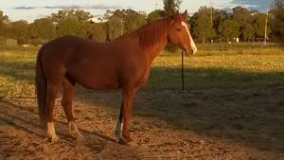 | Parkview Julia  AU-00-CH | Close Encounters  AU-85-BK | Contact  DE-74-B | Cor de la Bryere | Rantzau
 |  |  |  |  | Quenotte
 |  |  |  | Sektion | Grant II
 |  |  |  |  | Imsel
 |  |  | Caress Me II  AU-68-BR | Carioca | Felt Yet
 |  |  |  |  | Sing Again
 |  |  |  | Lovenest | Kilokan
 |  |  |  |  | Eagle's Nest
 |  | Parkview Rapunzel  AU-8x | Clever  AU-66-CH | Better Boy | My Babu
 |  |  |  |  | Better So
 |  |  |  | Golden Chariot | Golden Sovereign
 |  |  |  |  | Speed
 |  |  | unknown | unknown | unknown
 |  |  |  |  | unknown
 |  |  |  | unknown | unknown
 |  |  |  |  | unknown

